**Case 1 This case is divided into the following 3 main Steps A, B, C**

1. Storge account---à B. Azure SQL DB---à C. Power Bi Desktop.

In step **A** we will create a Storge account and configure it with data lake gen 2 then create a container and upload a bacpac file in it.

In Step **B** we will create an Azure SQL Server using Azure portal and connect that to MSSM and Restore bacpac file in Azure SQL Server.

In Step **C** we will connect the Azure SQL Database to Power BI Desktop.

**A**. **Storage account Gen2 and Upload a bacpac file in a Container.**

In the following steps, we will Create - Storage Account Data Lake Gen2 > Container > Upload “sample. bacpac”.

**Step1** Select a Storage Account. Note: <Create using Azure Portal>.

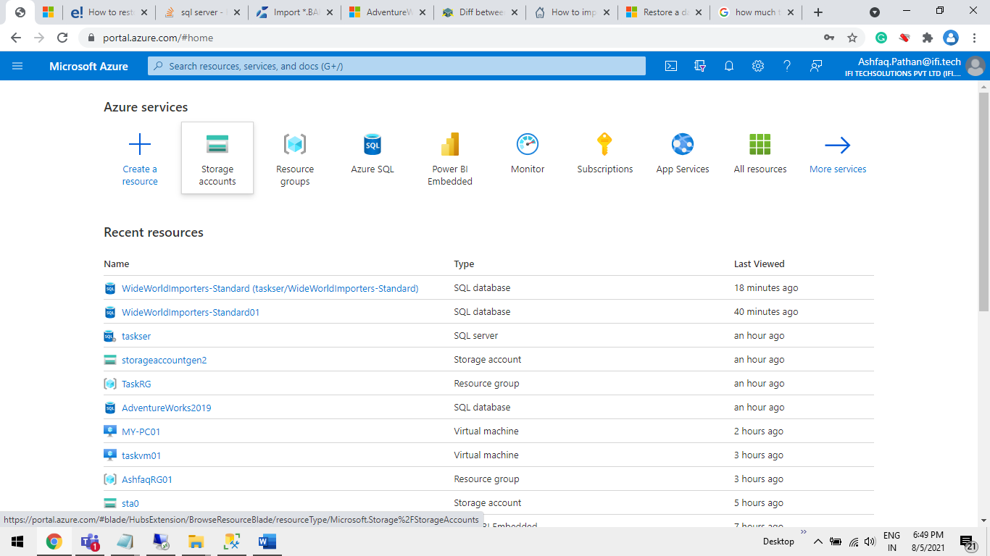

**Step2** Click on the **“+ Create** “Button.

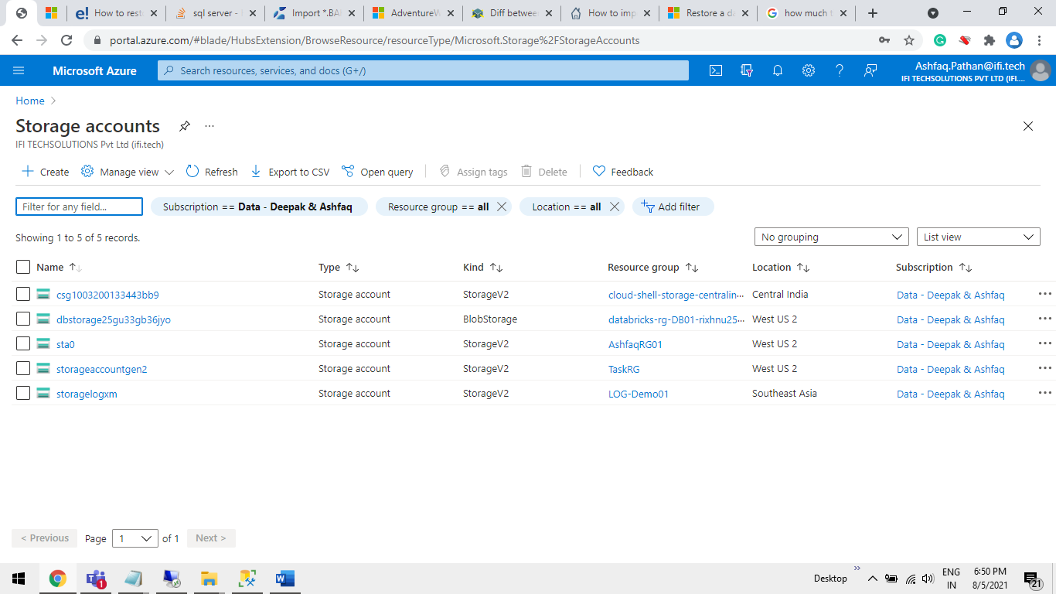

**Step3** Enter data as shown below and click the “**Next: Advanced**” Button.

**Subscription:**<Your azure Subscription select from Drop-Down>  
**Resource group**:<Select from Drop-Down / Create a new one>  
**Storage account name**:<Give any Name for Storage account>

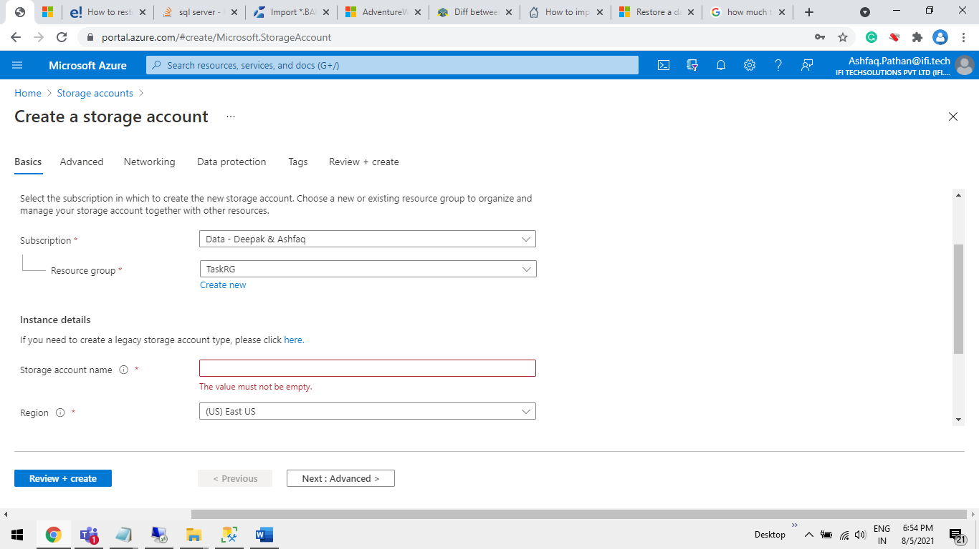

**Step4** Click on “**Enable Hierarchical namespace**” Check box < Note: This will Configure this storage account as “Data Lake Gen 2”> click on the “**Review + Create**” Button.

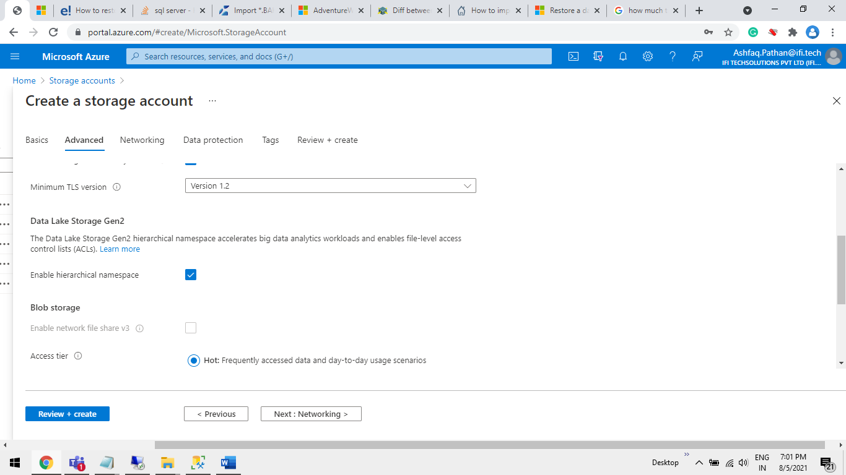

**Step5** Upload “Sample.bacpac” in your Storage Account.  
 Step 5.1 open Storage account Click on “Containers”.

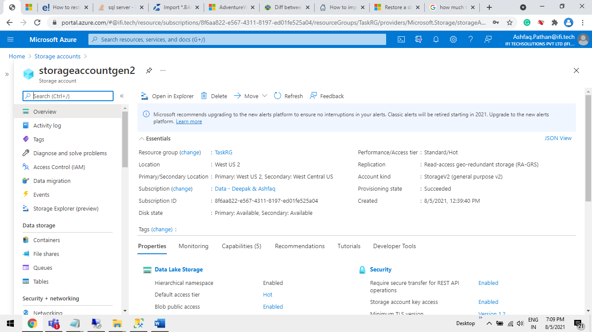

**Step 5.2** Click on **“+ Container**” to create a New Container.

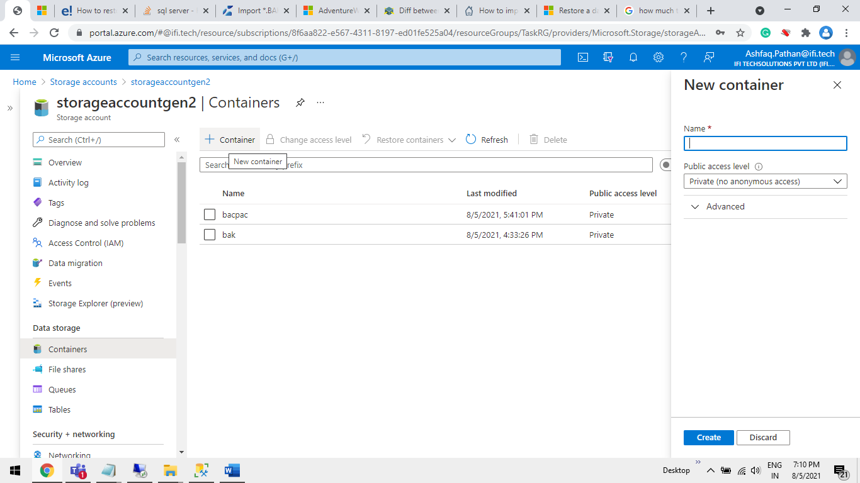

**Step5.3** Enter a name <bacpac> of a Container and click on “**Create**” Button

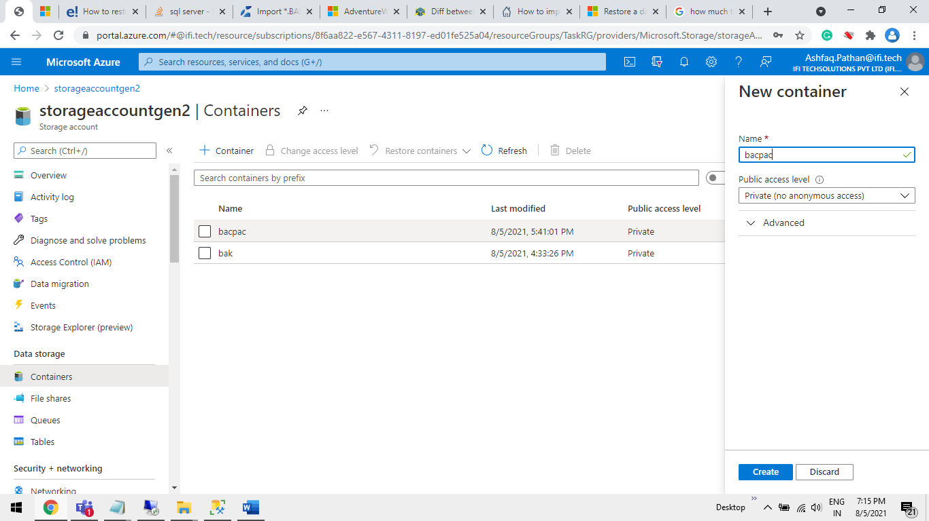

**Step5.4** Open “bacpac **Container**” Click on “**upload**” Button.

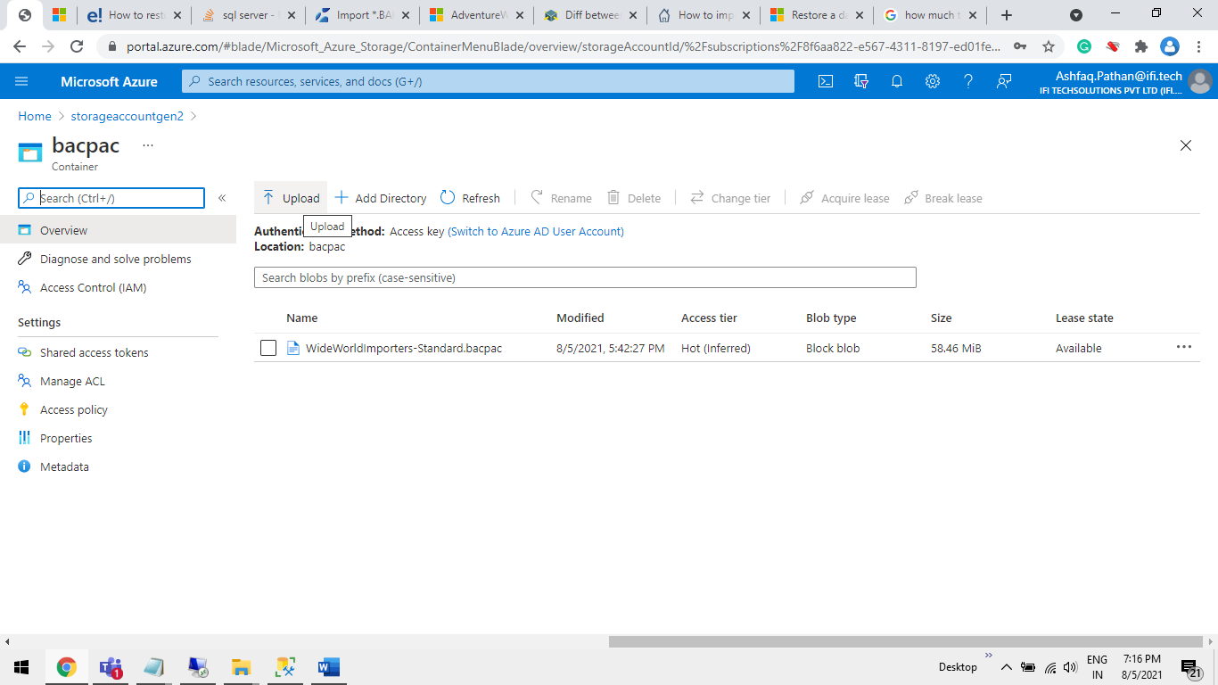

**Step5.5** Click on file Icon .

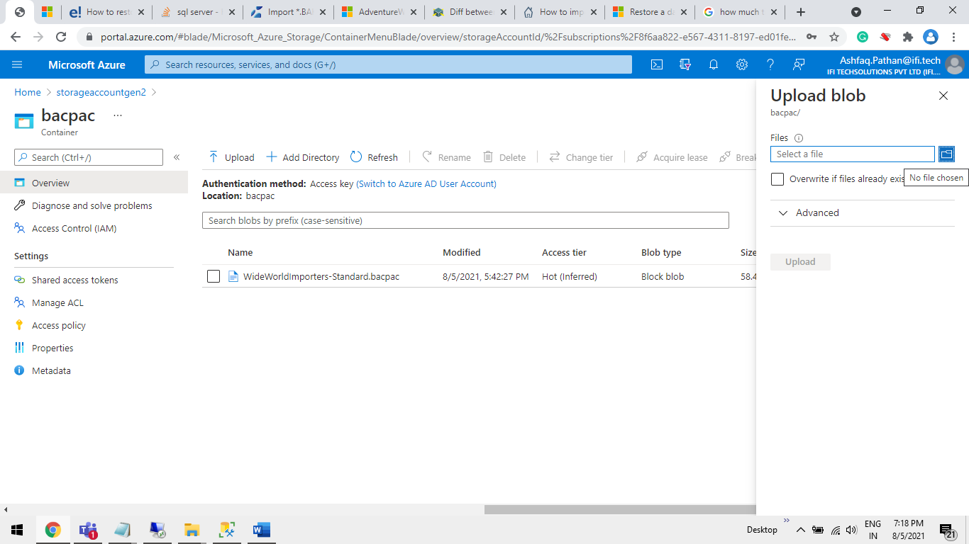

**Step5.6** Select a “**datafile**. **bacpac**” file from Local System and Click on Open Button.

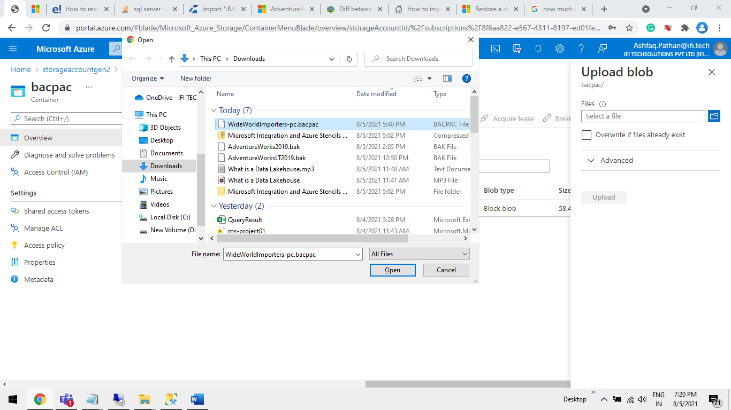

**Step5.7** Click on “**Uplode**” Button.

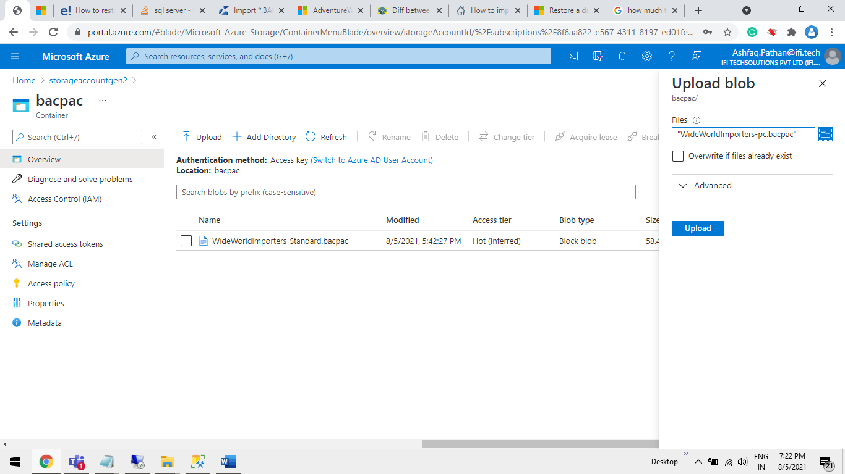

**Step5.8** Check The “**Lease State**” is Available.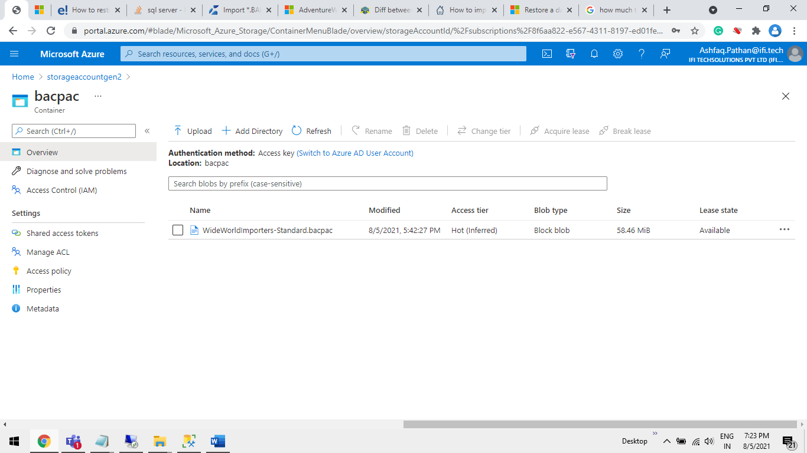

**B**. **Create** **an Azure SQL DB Using Azure Portal and Restore bacpac file In It.**

In the following Steps we will Create – **Azure SQL DB**, and we will see How to restore bacpac file. In **Azure SQL** using **MSSM**.

**Step1** Select **Azure SQL** from **Azure Portal**.

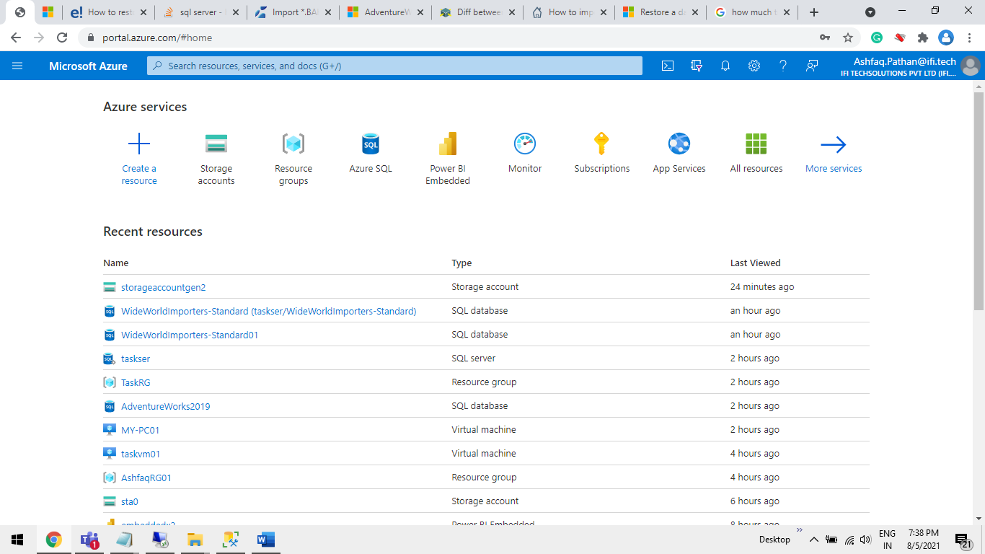

**Step2** Click on **“+ Create**” Button.

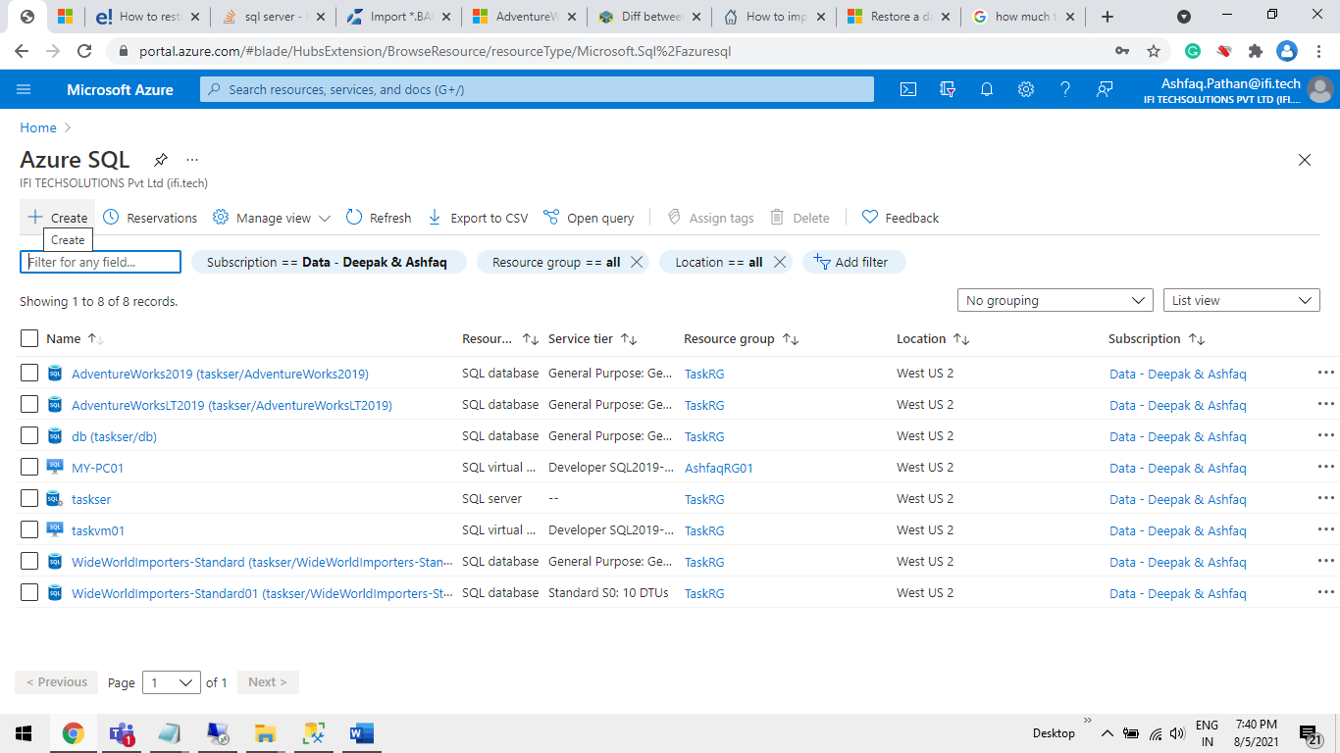

**Step3** Select “**Database Server**” and click on “**Create**” button.

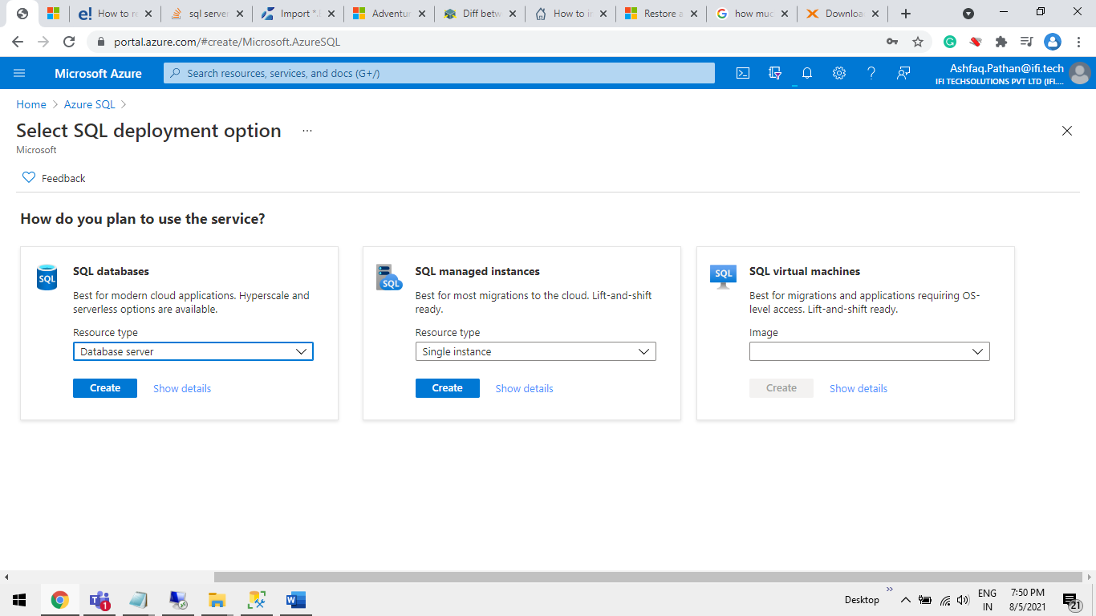

**Step4** Enter data as given below.

**Server name**: <Give a server name eg: serverxyz>  
**Server admin login**: <User id eg: test123>  
**Password:** <Enter password eg:@1234xyz>  
**Confirm password:**<same as password>

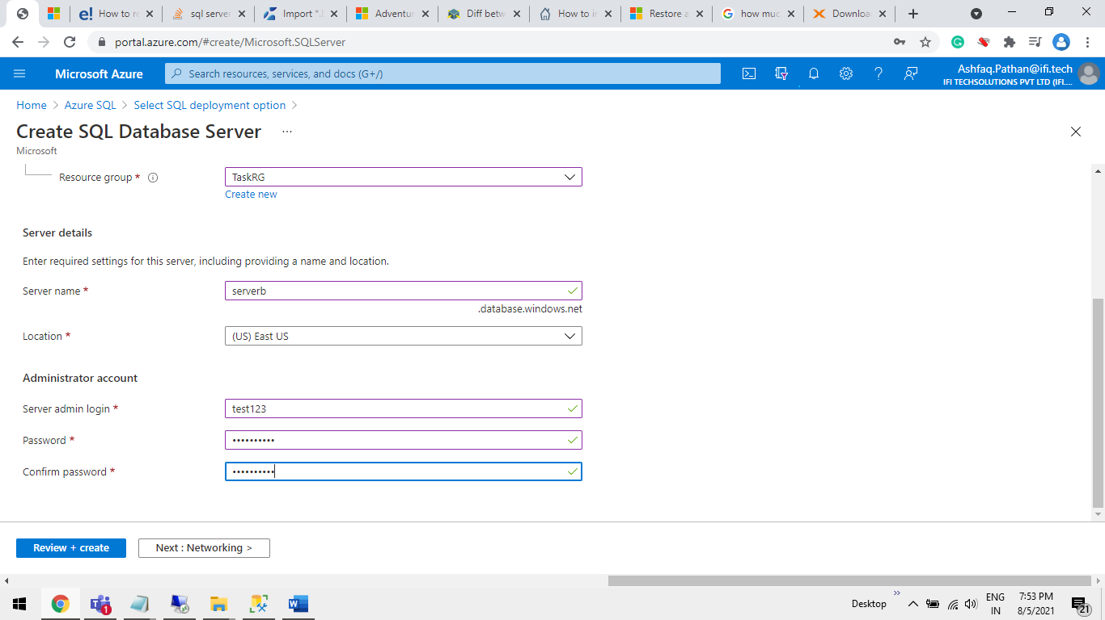

**Step5** “**Allow Azure services and resources to access this server**” Select Yes. and click on   
“**Review + Create**” Button.

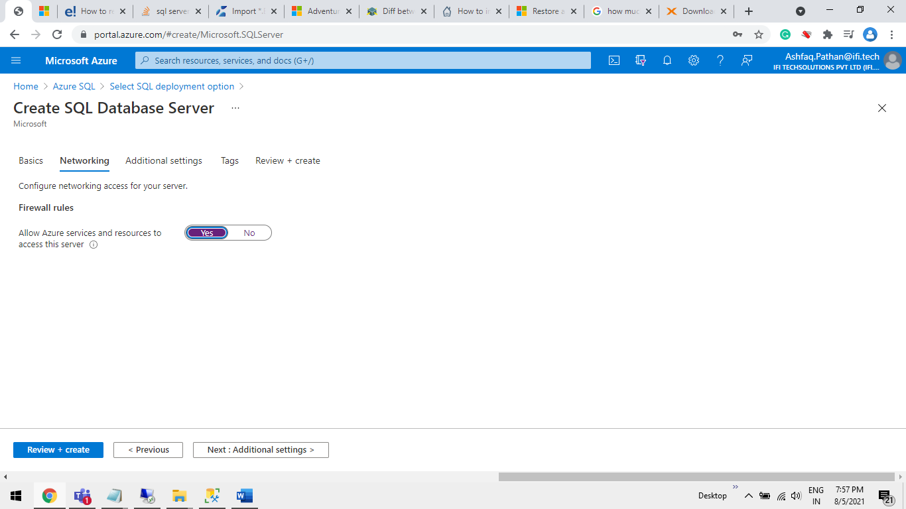

**Step6** Restore bacpac using MSSM.

**Step6.1** From your system open “**Microsoft SQL Server Management Studio**”.

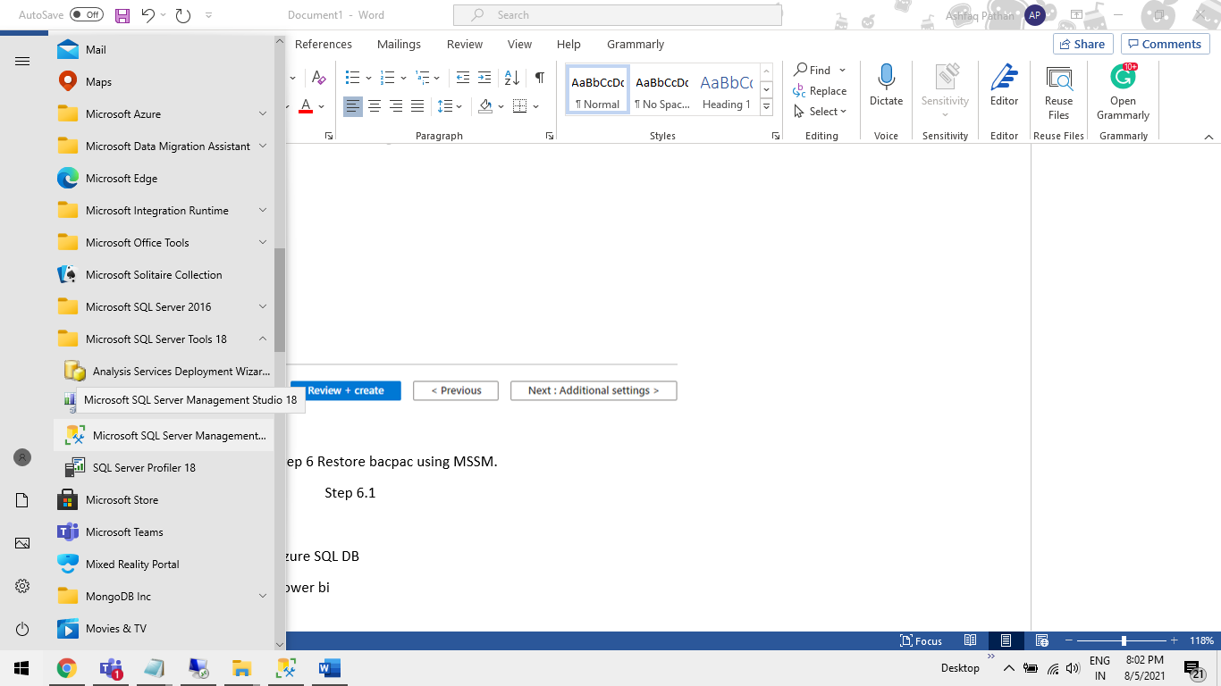

**Step6.2** Click on “Connect” Select “Database Engine..”.

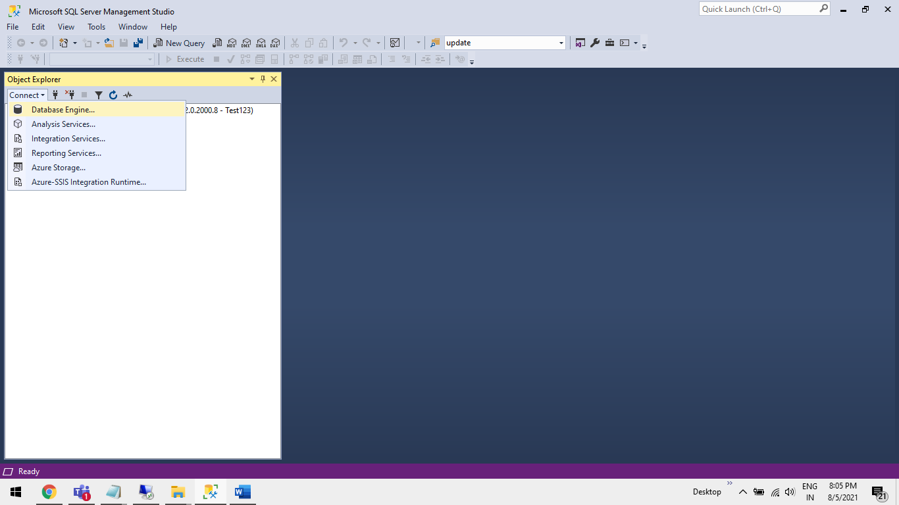

**Step6.3** Enter data as given below.

**Server name**: <server-name>.database.windows.net  
**Login**: <Server user id>  
**Password**: <Server password>

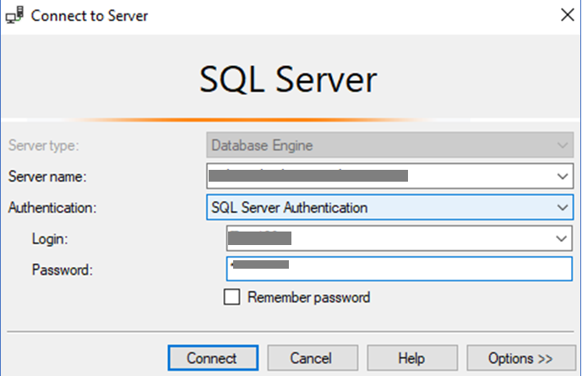

**Step6.4** Server is Connected.

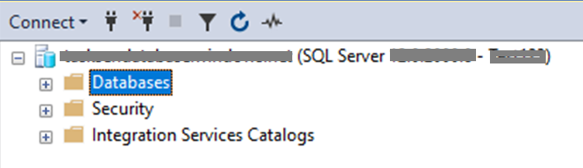

**Step6.5** Right Click on Database Folder and select **“Import Data-tier Application**…”.

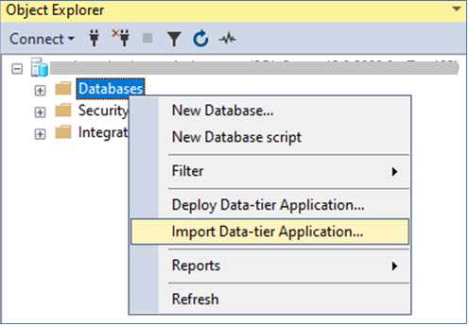

**Step6.6** Click on “**Next”** Button.

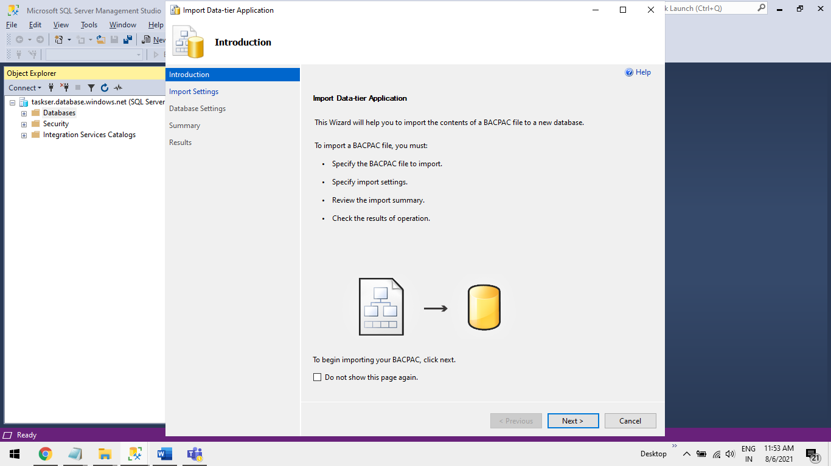

**Step6.7** Click on “**Connect”** Button.

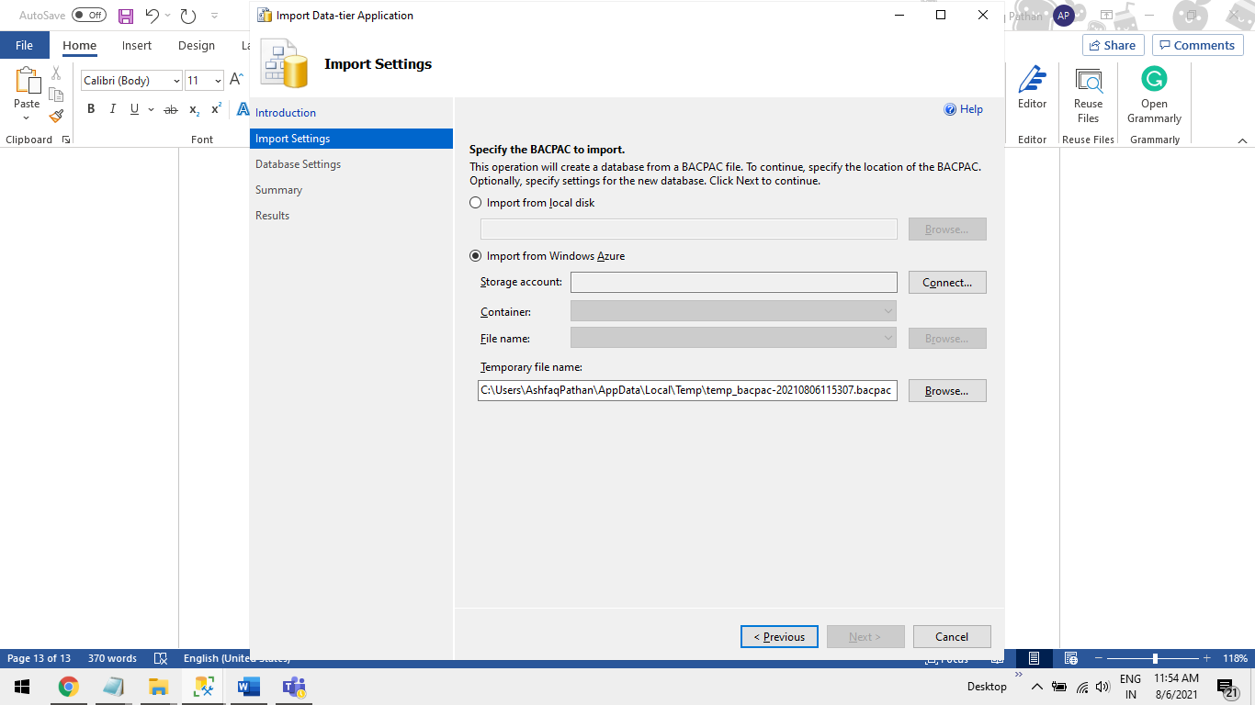

**Step6.8** Click on “**Sign in**” Button

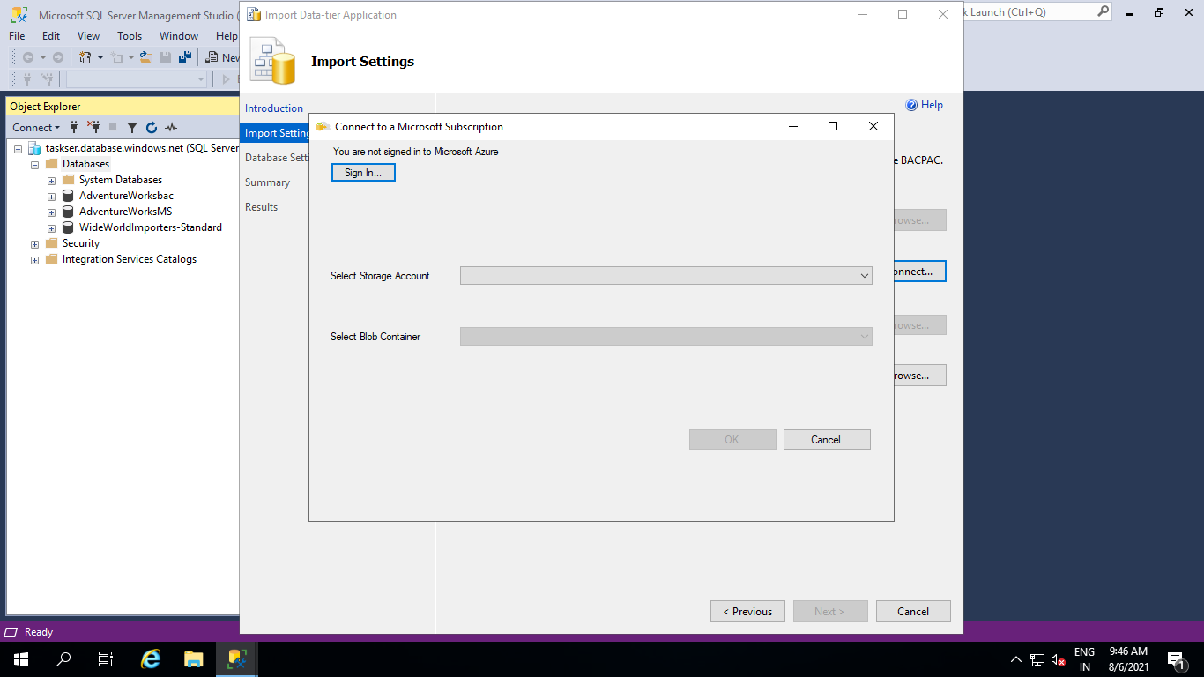

**Step6.9** Enter your Email Address same as used in Azure Portal

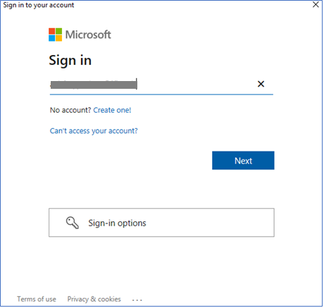

**Step6.10** Enter password and click on “**Sign in**” Button.

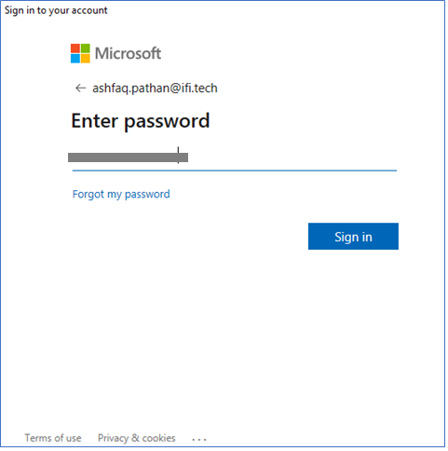

**Step6.11** Select below Drop-Down and click on “**OK”** Button.

**Select a Subscription to use**: <Select in which you have your Storage account>  
**Select Storage Account**:<Select Storage account from drop-down>  
**Select Blob Container**:<Select Container from drop-down >

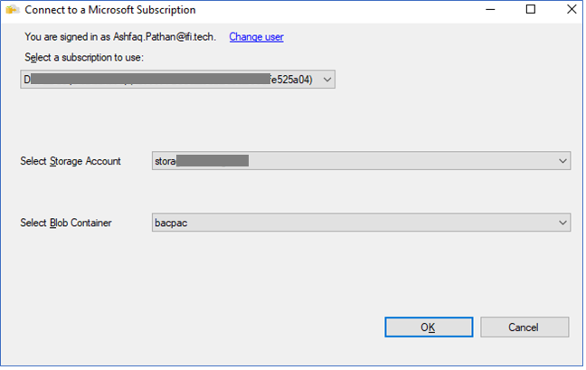

**Step6.11** Click on “**Next”** Button.

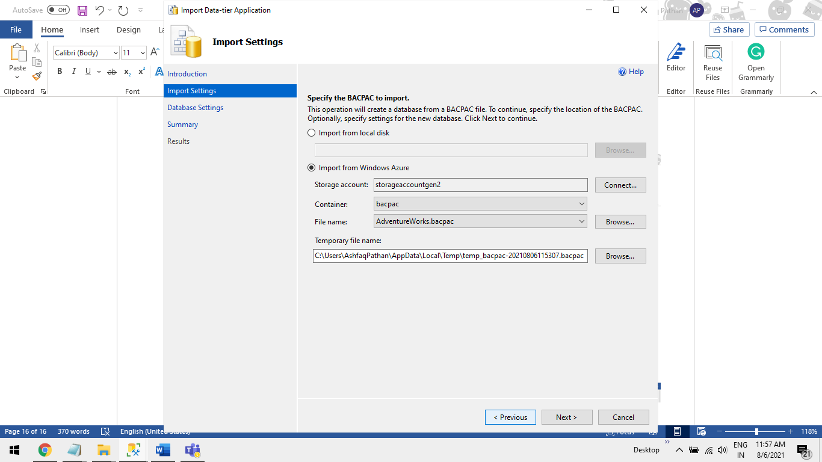

**Step6.12** < Note: Based on Your Requirement Configure the “**Microsoft Azure SQL Database Settings** “>

And click on “**Next”** Button.

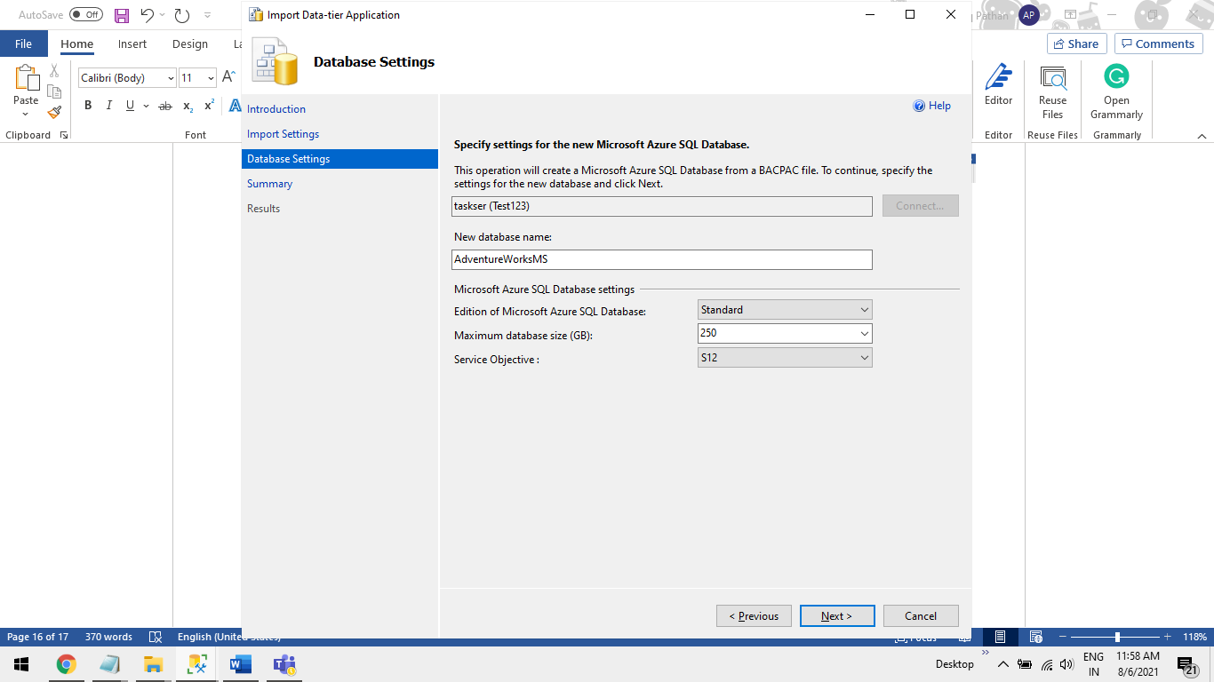

**Step6.13** Click on “**Finish”** Button.

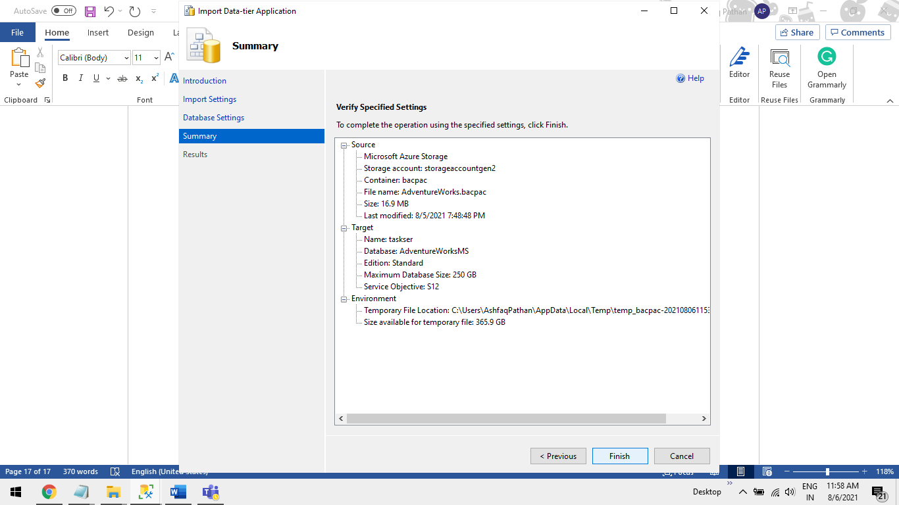

**Step6.14** On this wizard you will see all the Import progress.

**Note**: This step will take some time base on your Bacpac file size + The Pricing Tire you have configured in **Step6.12**.

For e.g.: It took 50 min approx. to import 53mb file size with Standard S0 Tire Configuration

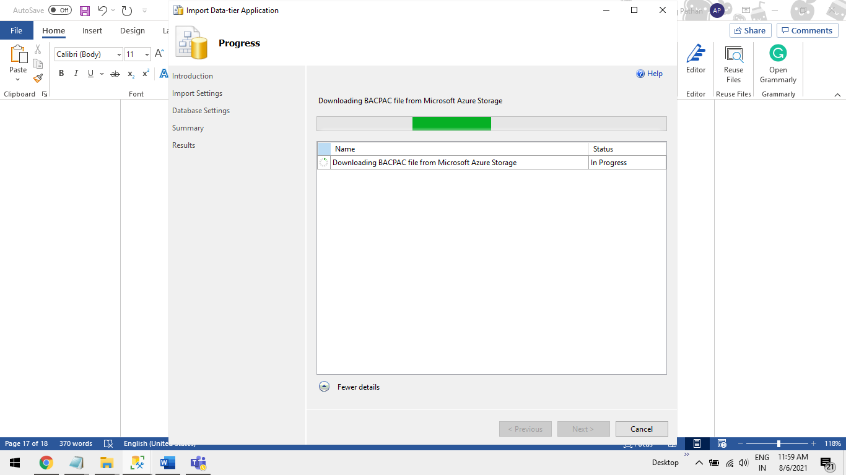

**Step6.15** Click on “**Close”** Button.

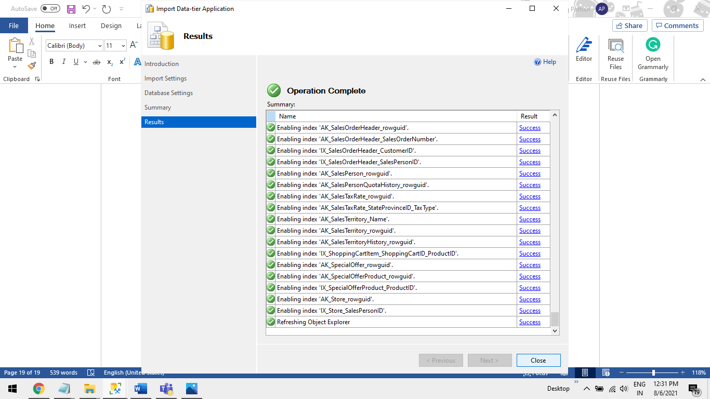

**Step6.16** Check the Database bacpac restore is completed.

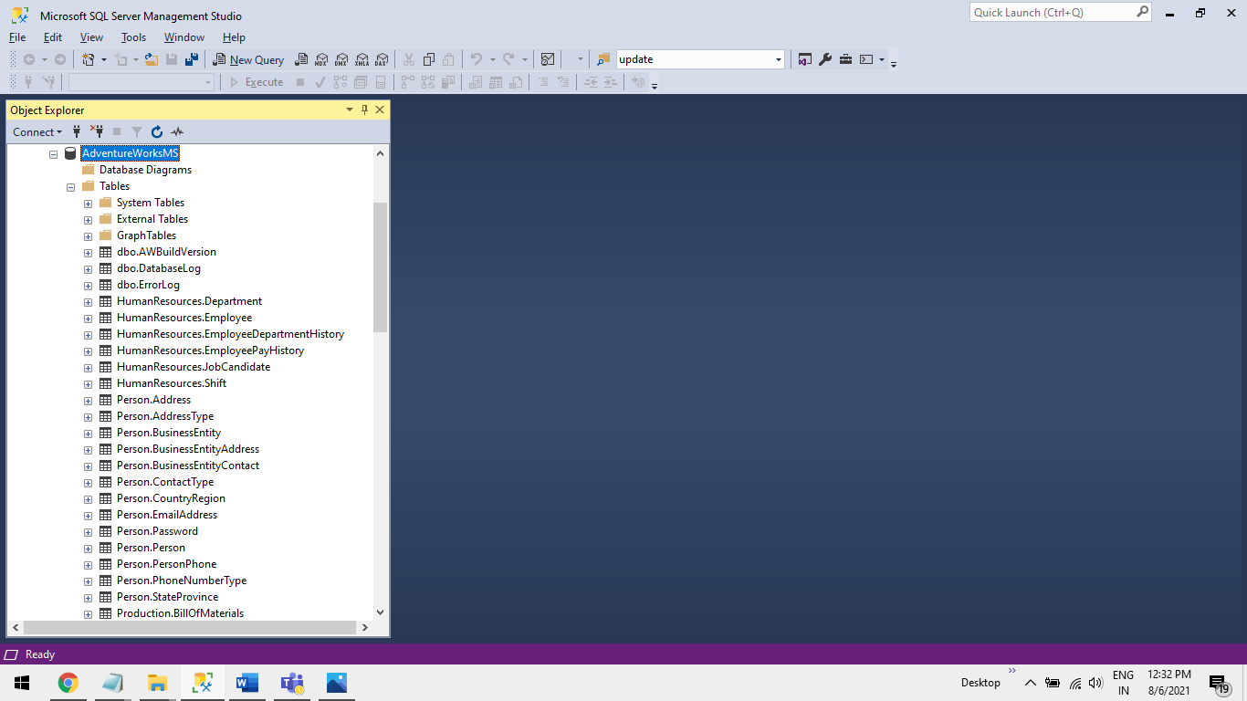

**C. Connect Azure SQL Database to Power BI Desktop App.**

**Step1** Open Power BI Desktop.

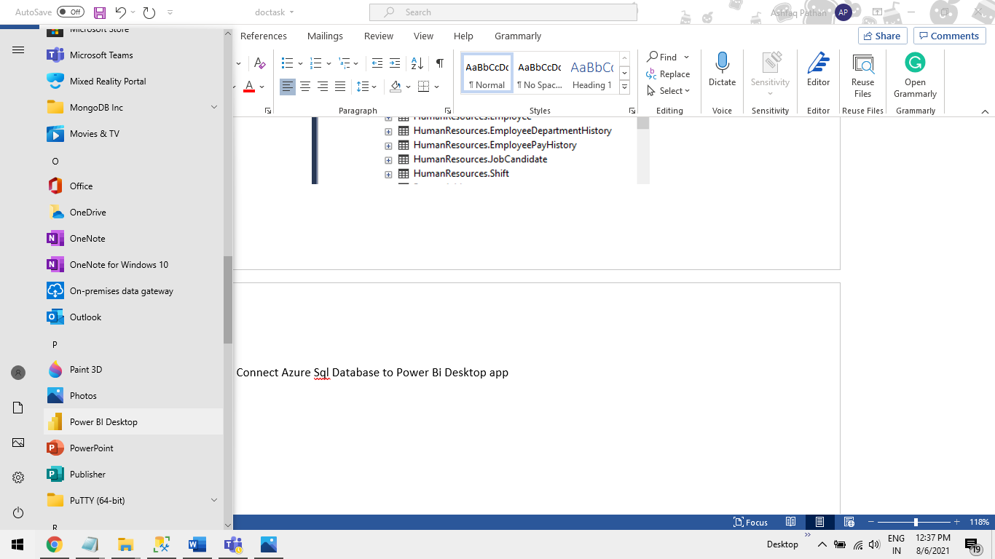

**Step2** Click on “**Get data**” from “**Home**” Tab.

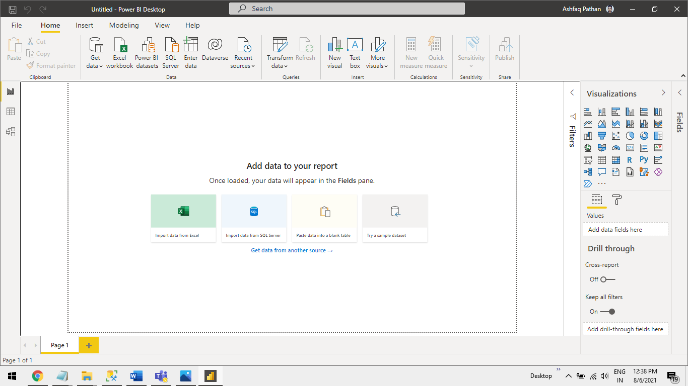

**Step3** Click on “**More”** Options.

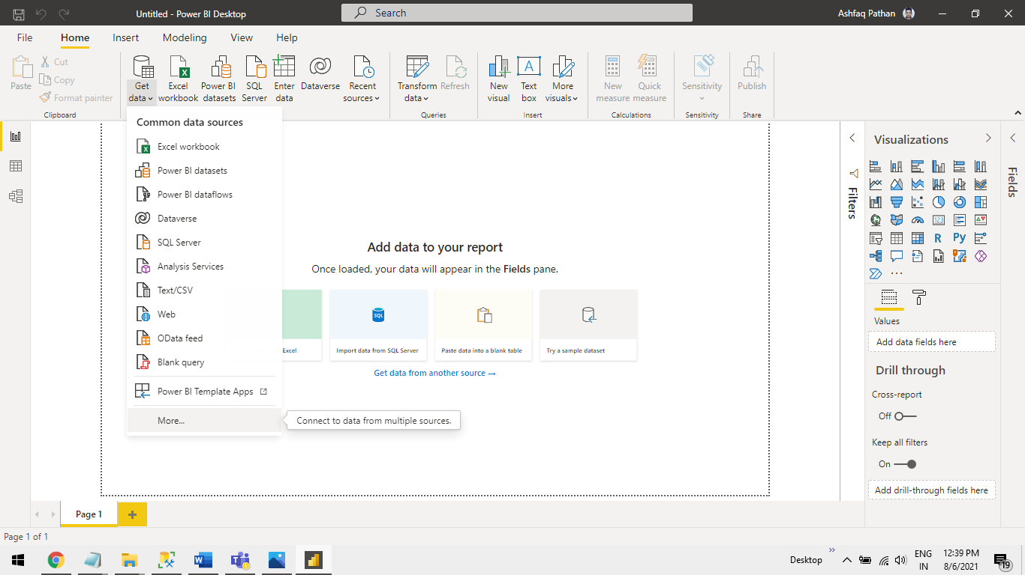

**Step4** Select “**Azure”** > “**Azure SQL Database”** and click on “**connect”** Button.

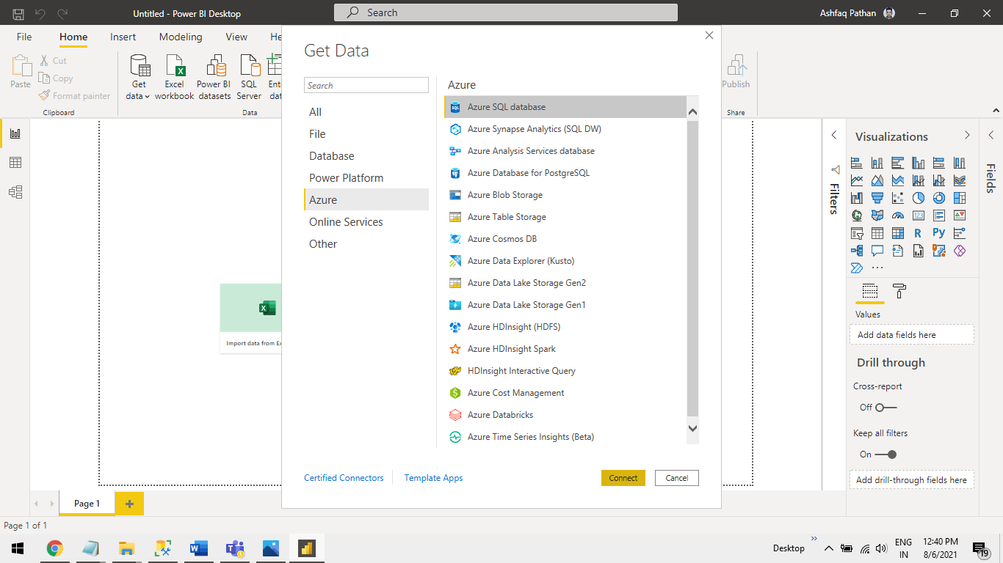

**Step5** Get Server name from Azure Portal and enter in Power BI.

**Step5.1** You will get the **Server name** from **Azure Porta**l > **Azure SQL server** > **Overview** > **Server name** >

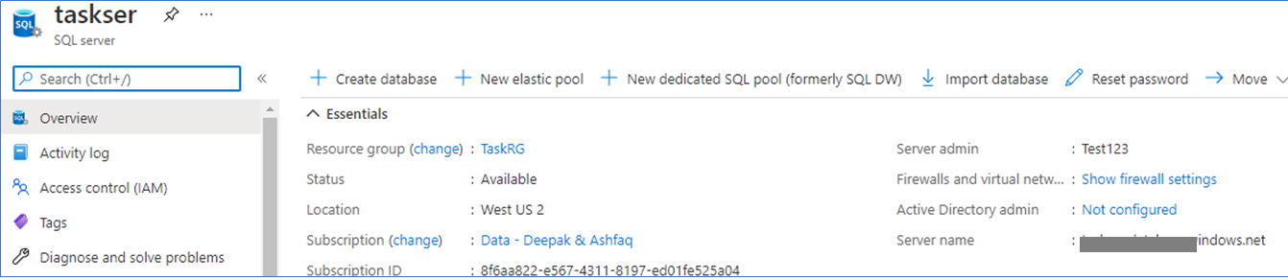

**Step5.2** Enter Server name click on “**Ok”** Button.

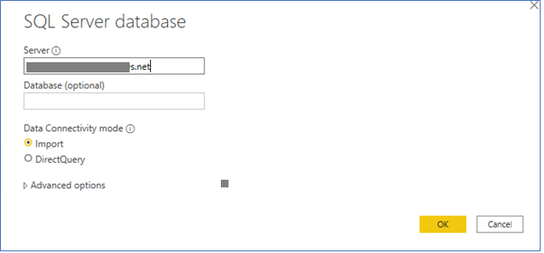

**Step6** Select “**Database**” option and add Azure SQL Server **User name**,**Password**. Click on “**Connect”** Button.

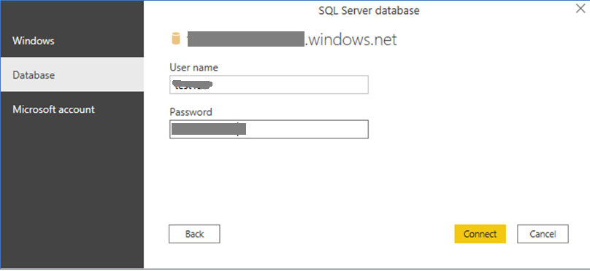

**Step7** Select **Database** > Select **table** in it and click on “**Load”** Button.

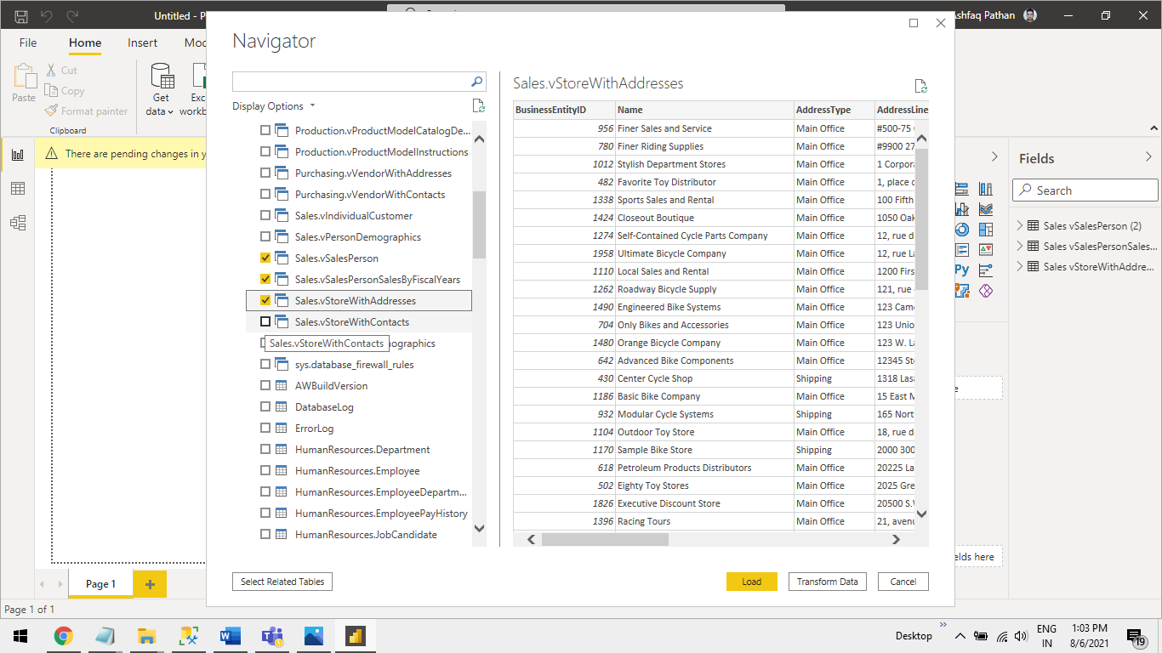

**Step8** Select Import Click on “**OK”** Button.

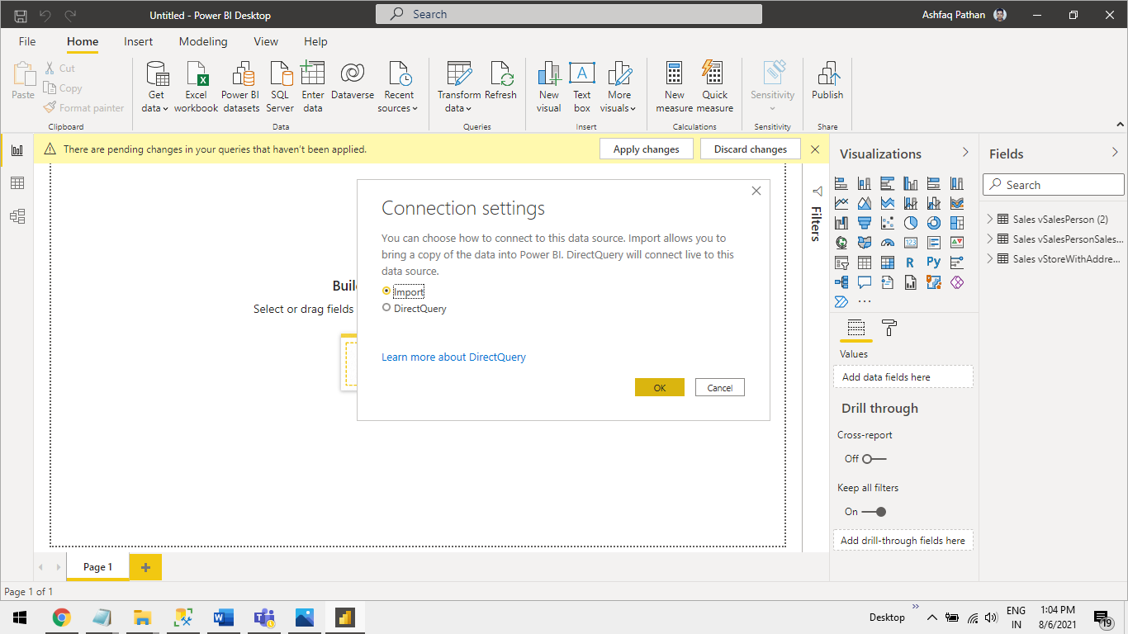

**Step9** This Will Lode dataset in Power BI.

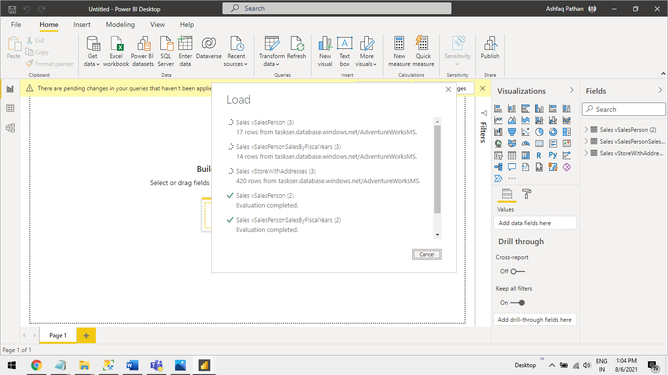

**Step10** You will See table in “**Fields”** tab In Power BI.

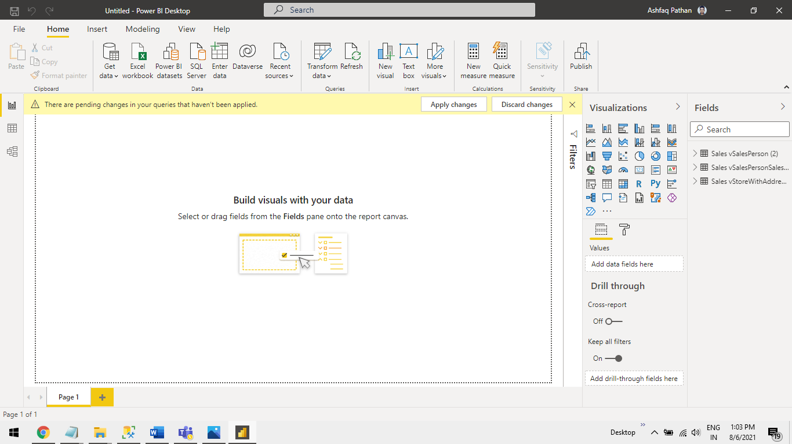

**Case 2 This Case is divided in to Following 3 main Steps E,F,G**

E Storge account -----à F. Azure SQLVM-----à G. Power Bi Desktop.

In step **E** we will create a Storge account and configure it with **data lake gen 2** then create a container and upload a .**bak** file in it.

In Step **F** we will create an Azure SQL-VM using azure portal and connect that to **MSSM** and Restore bak file in Azure SQL-VM .

In Step **G** we will connect the Azure SQL-VM to Power BI Desktop.

**E**. **Storage account Gen2 and Upload a .bak file in a Container.**

In the following Steps we will Create - Storage Account **Data Lake Gen2** > **Containe**r > **Upload** “sample. bak”.

**Step1** Select a Storage Account. Note: <**Create using Azure Portal**>.



**Step2** Click on **“+ Create** “Button.



**Step3** Enter data as shown below and click “**Next: Advanced**” Button.

**Subscription:**<Your azure Subscription select from Drop-Down>

**Resource group**:<Select from Drop-Down / Create a new one>

**Storage account name**:<Give any Name for Storage account>



**Step4** Click on “**Enable Hierarchical namespace**” Check box < Note: This will Configure this storage account as “Data Lake Gen 2”> Click on “**Review + Create**” Button.



**Step5** Upload “**Sample.bak**” in your Storage Account.

**Step5.1** open Storage account Click on “**Containers**”



**Step5.2** Click on **“+ Container**” to create a New Container.



**Step5.3** Enter a name <**bak**> of a Container and click on “**Create**” button

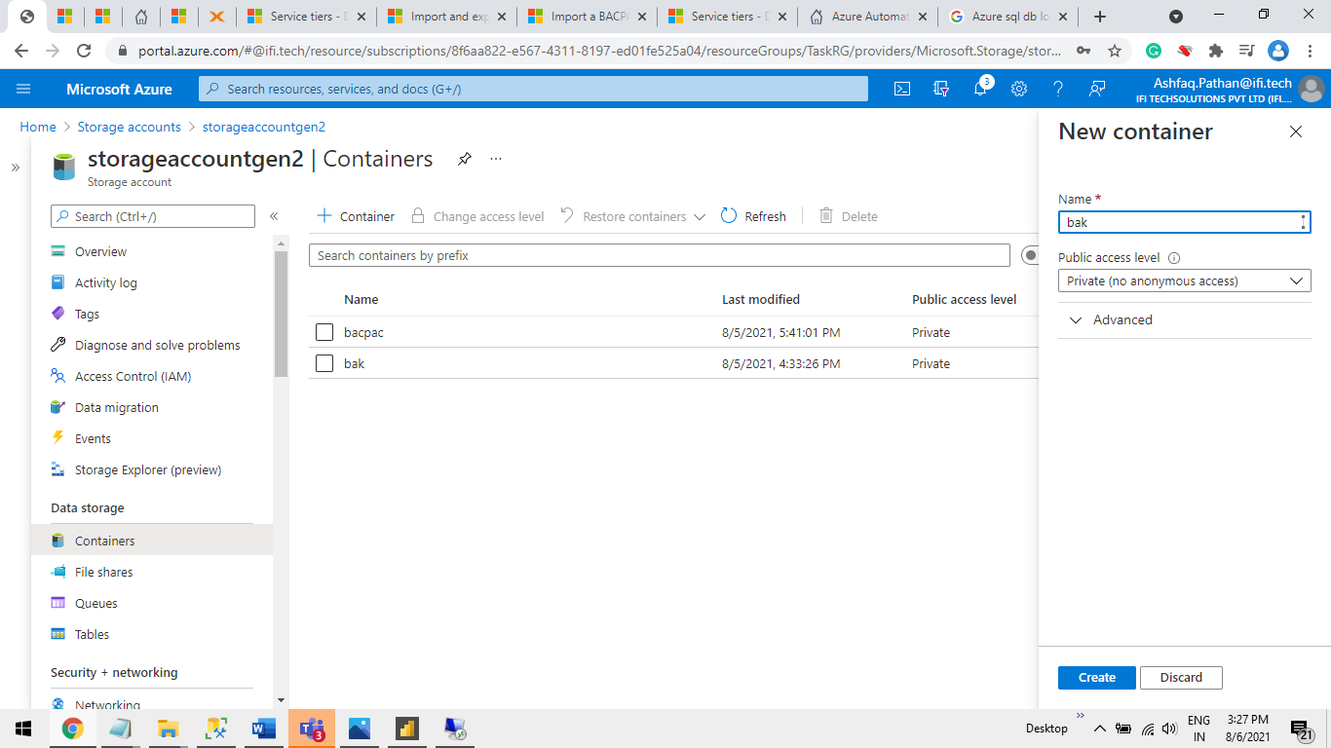

**Step5.4** Open “bacpac Container” Click on “upload” Button.

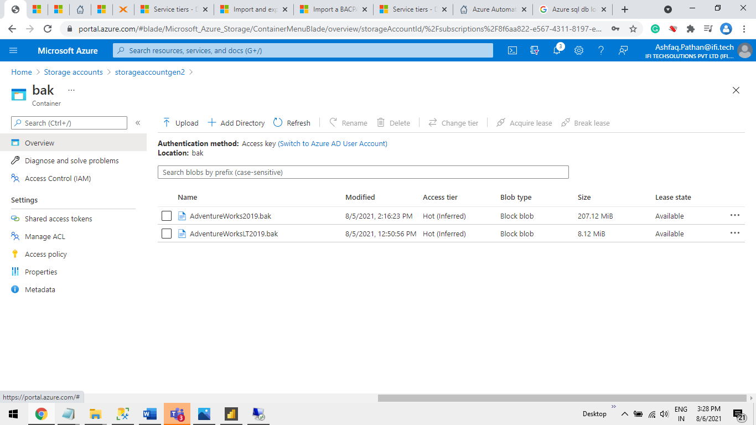

**Step5.5** Click on File icon .

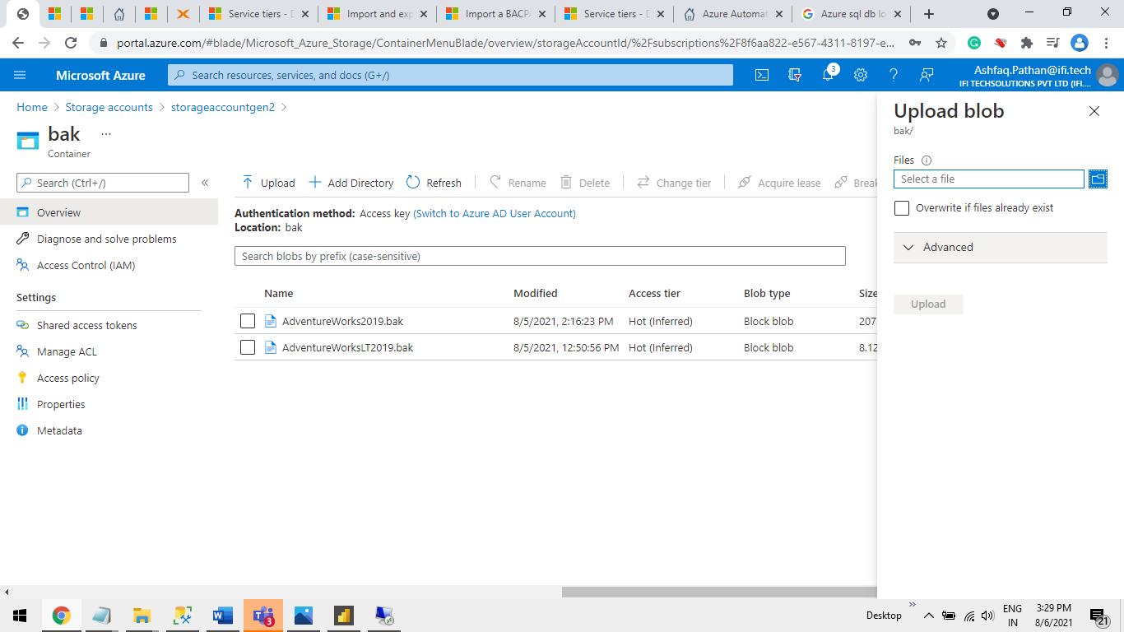

**Step5.6** Select a “**datafile.bak**” file from Local System and Click on “**Open”** Button.

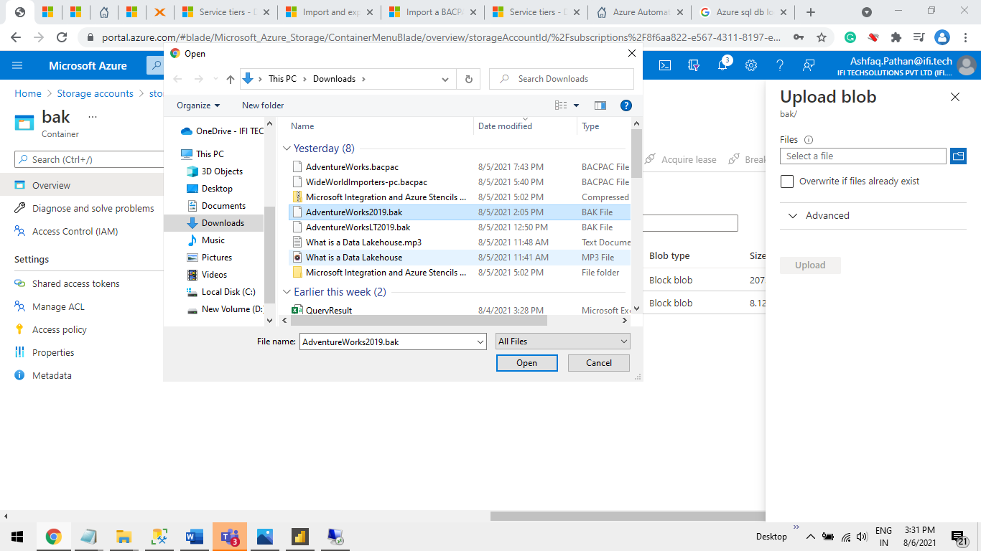

**Step5.7** Click on “**Uplode**” Button.

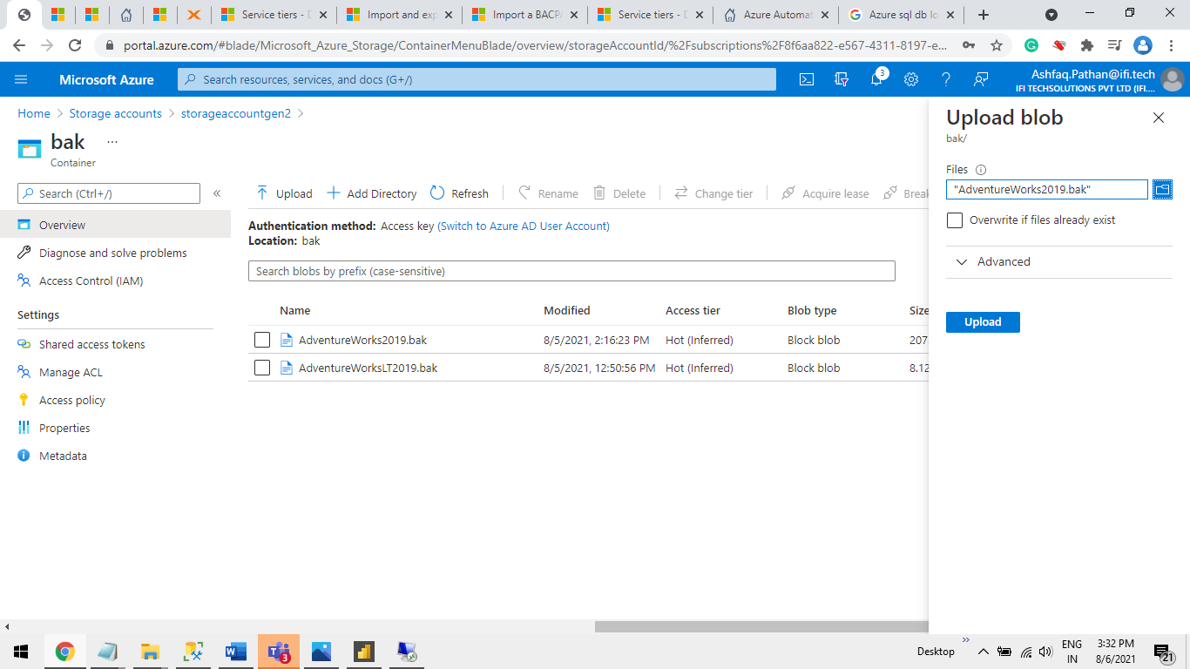

**Step5.8** Check The “**Lease State**” is Available .

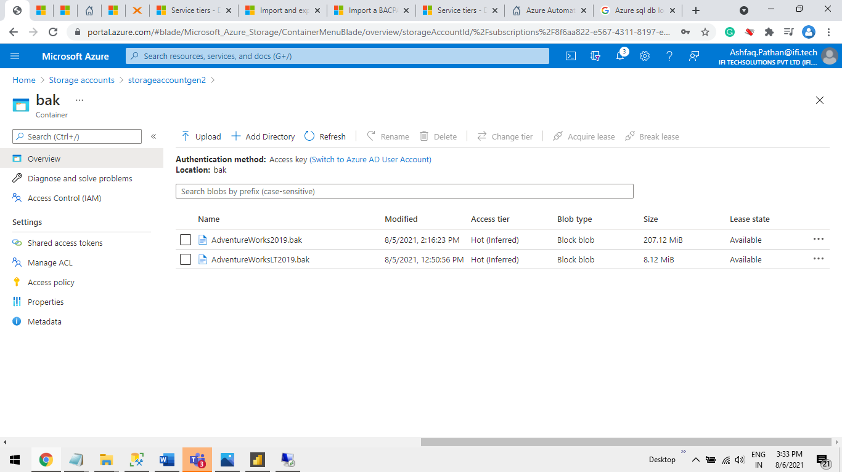

**F. Create an Azure SQL-VM using azure portal and connect that to MSSM and Restore bak file in Azure SQL-VM**.

**Step1** Open azure Portal and select **Azure SQL** to create Azure SQL-VM.

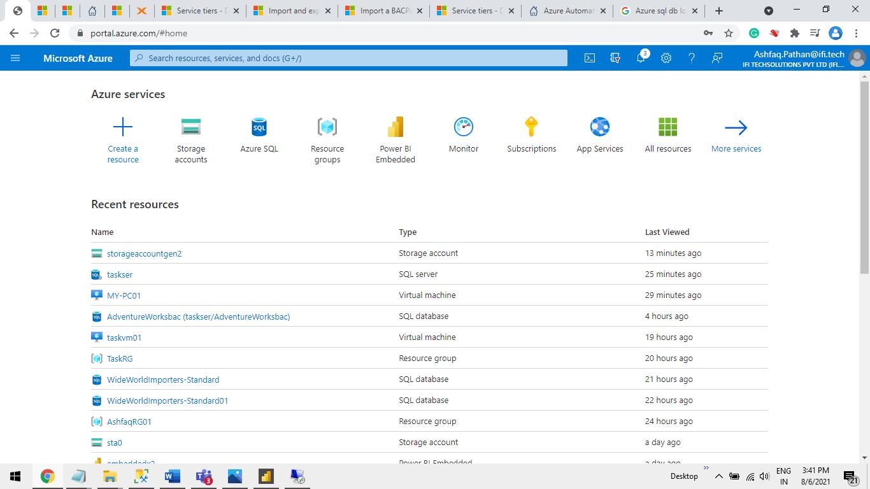

**Step2** Click on “**+ Create”** Button.

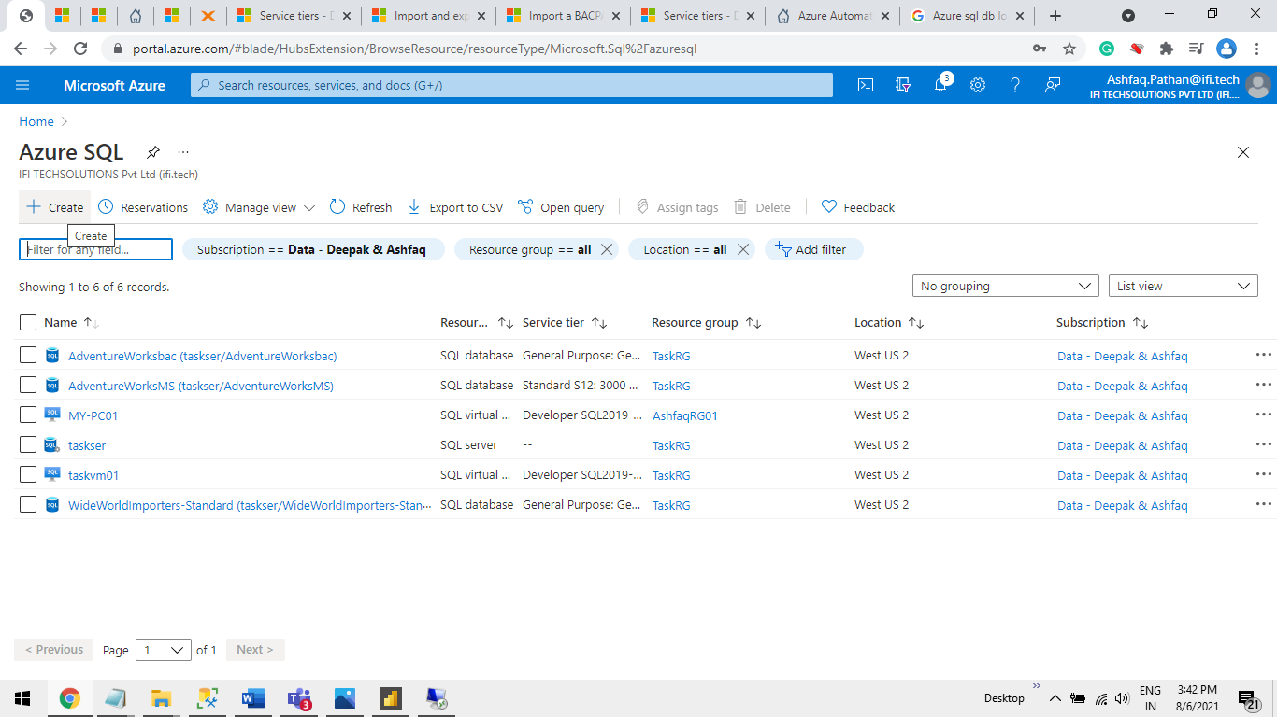

**Step3** Select **“SQL Virtual machines”.**

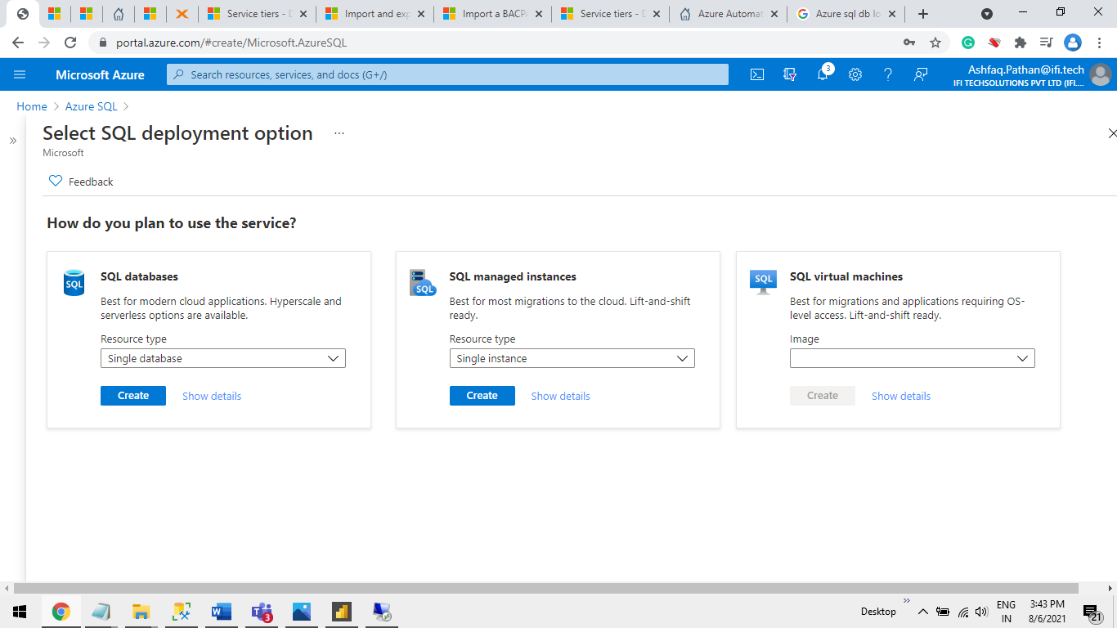

**Step4** Select **Image** from Drop-down “**SQL 2019 Developer**”. And Click on “**Create”** Button.

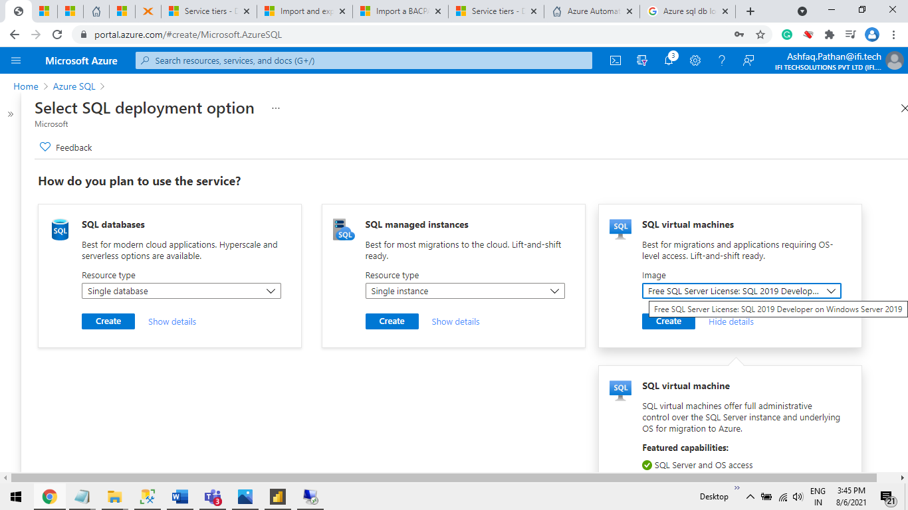

**Step5** Configure VM

**Step5.1** Enter Below data and click on “**SQL Server Settings**” tab.

**Virtual machine name**: <Give VM name >  
**Image**: <Select 2019 Developer>  
**Size**: <Select VM Size based on your requirement>  
**Username**: <Give VM User Log in name e.g.: “test123”>  
**Password** :<password>  
**Confirm password**:<same as entered in password>

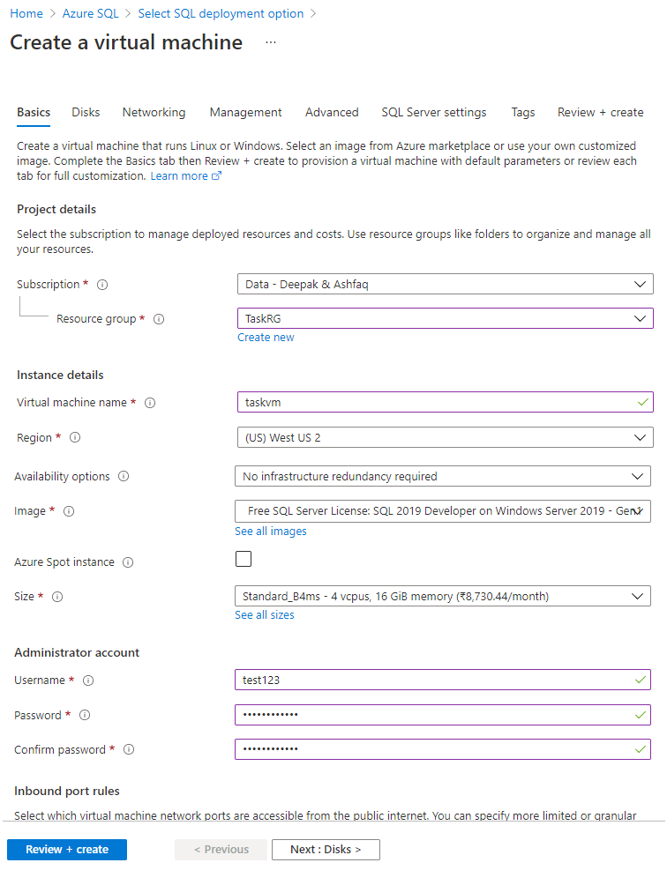

**Step 5.2** Select option same as given below.

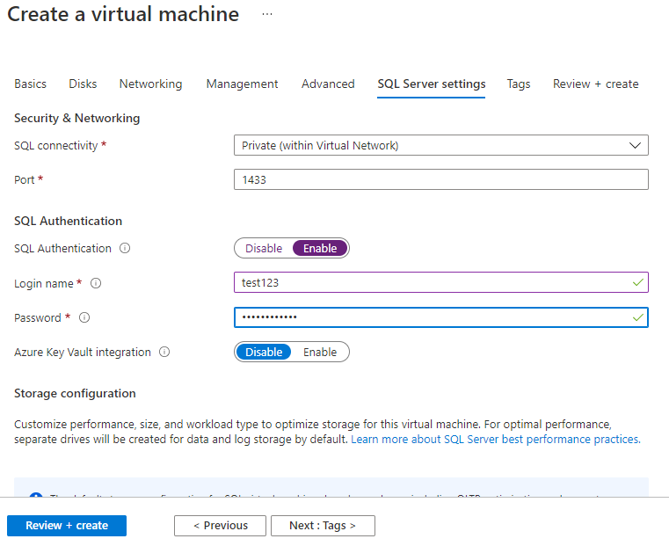

**Step6** Copy Ip address to open VM in Remote Desktop.

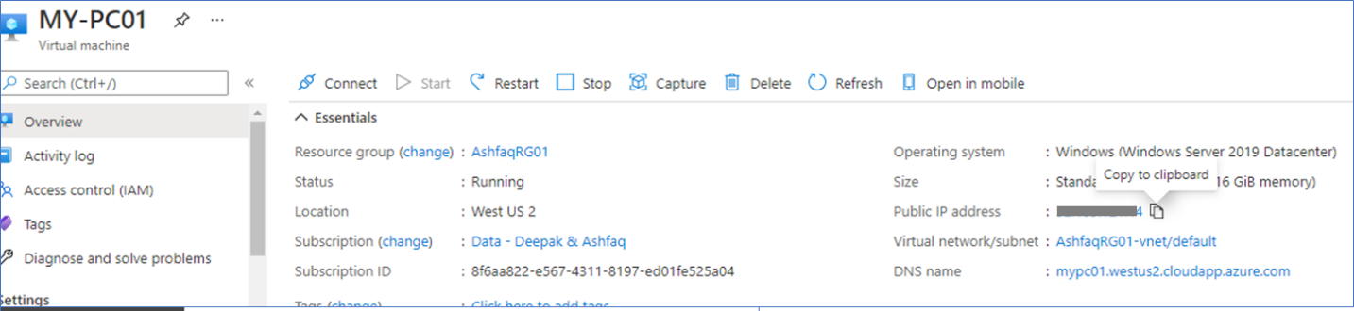

**Step7** Open Remote Desktop.

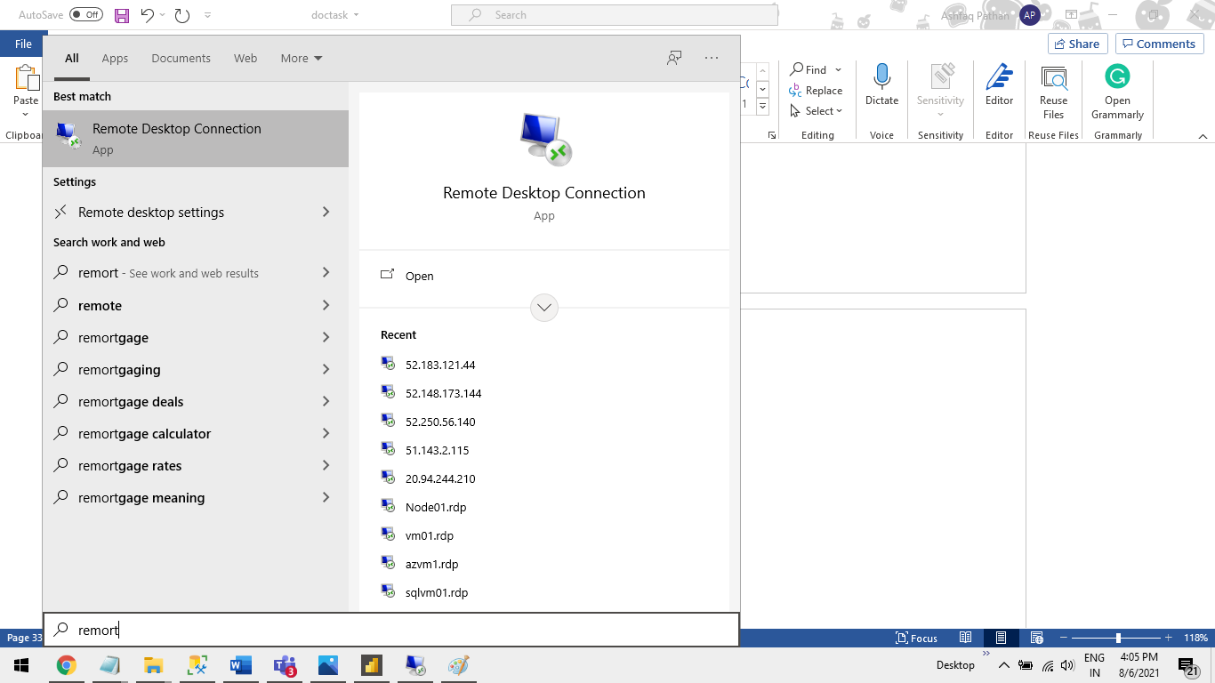

**Step8** Enter Ip address and Click on **Connect** Button.

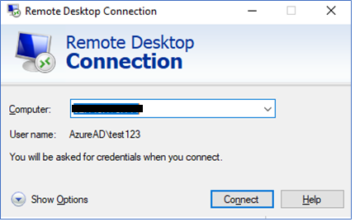

**Step9** Open MSSM in VM**.**

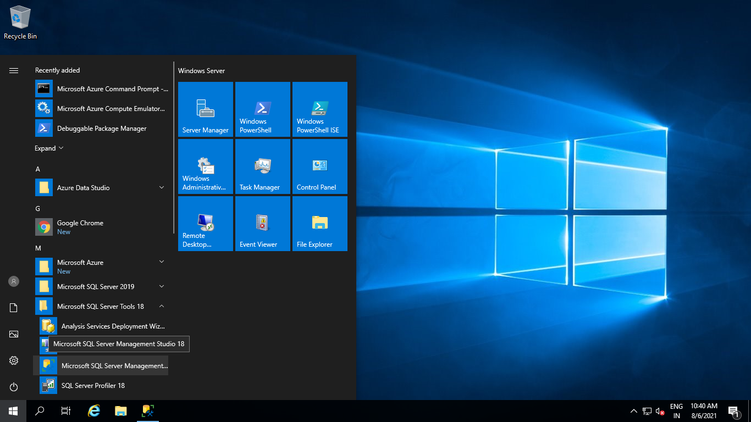

**Step10** Click on **Connect** Button.

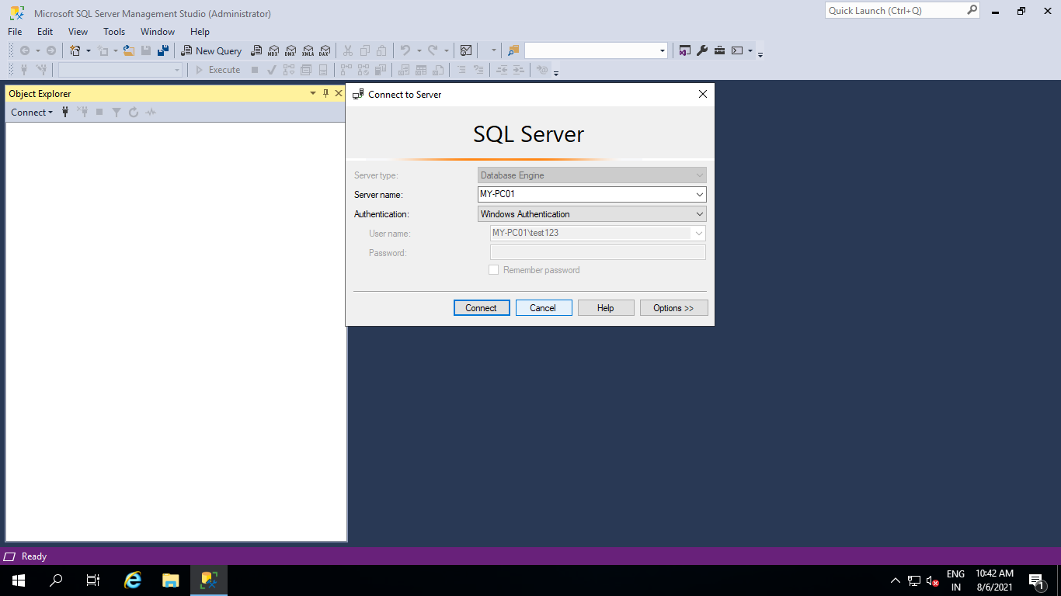

**Step11** Right Click on **Databases** and select **Restore Database…**

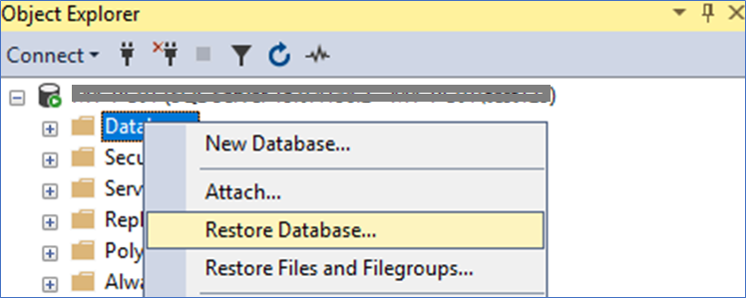

**Step11.1** Select **Device** Option and Click on 3 Dot .

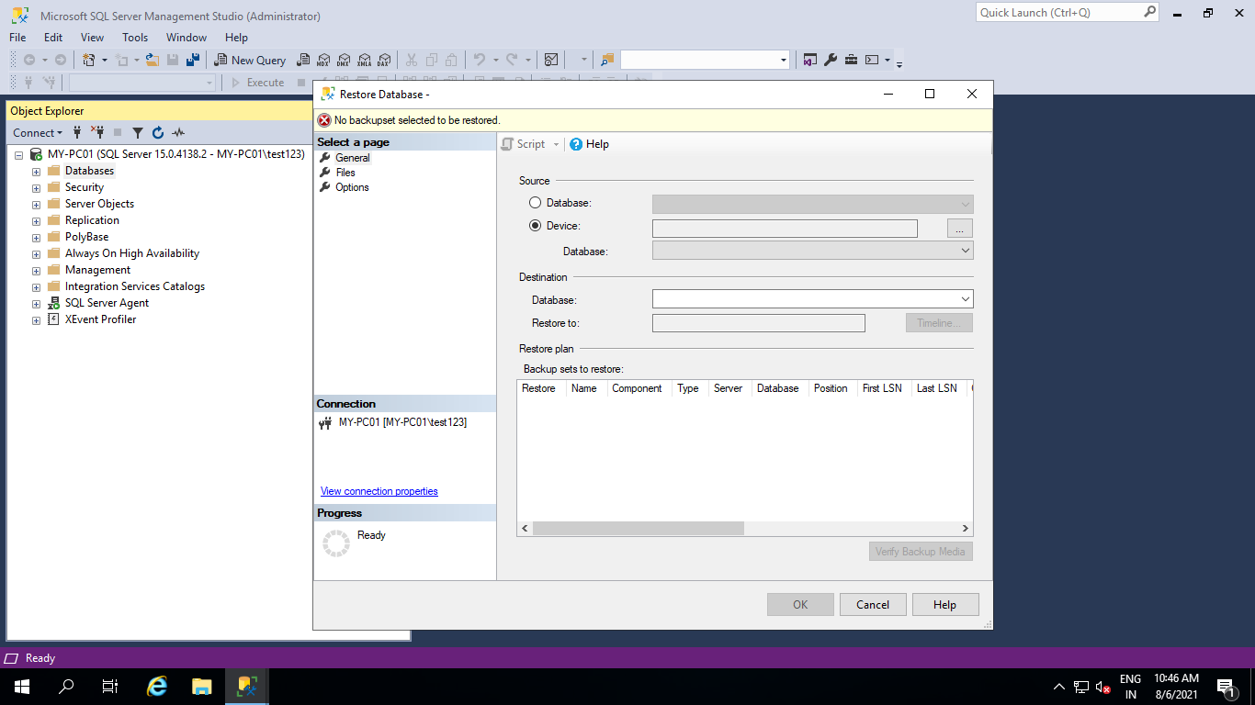

**Step11.2** Select **URL** From **Backup media type:** and Click on **Add** Button.

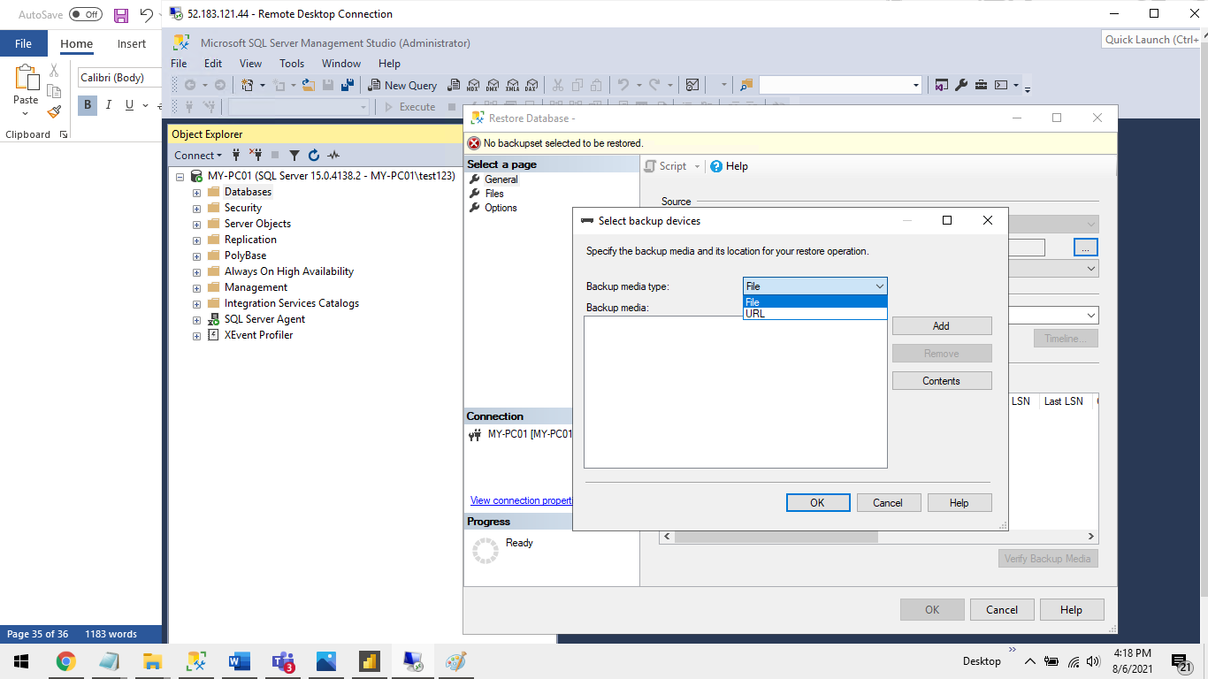

**Step11.3** Click on **Add** Button.

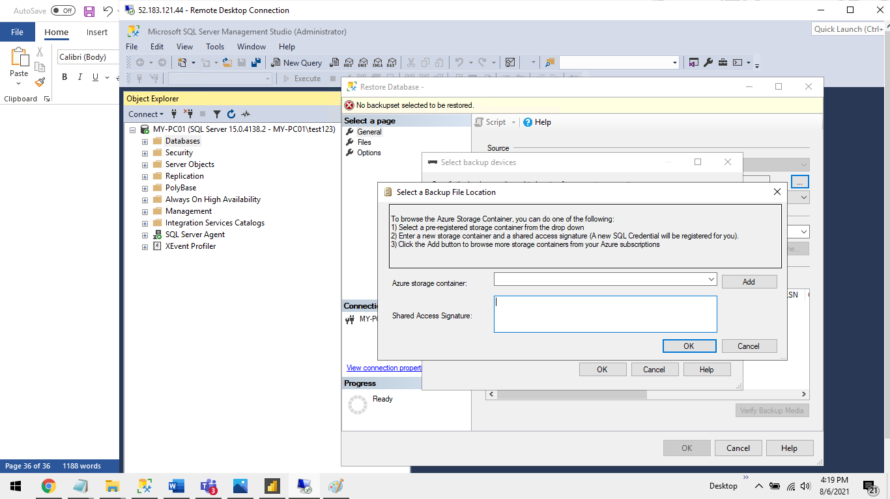

**Step11.4** Click on “**Sign in**” Button.

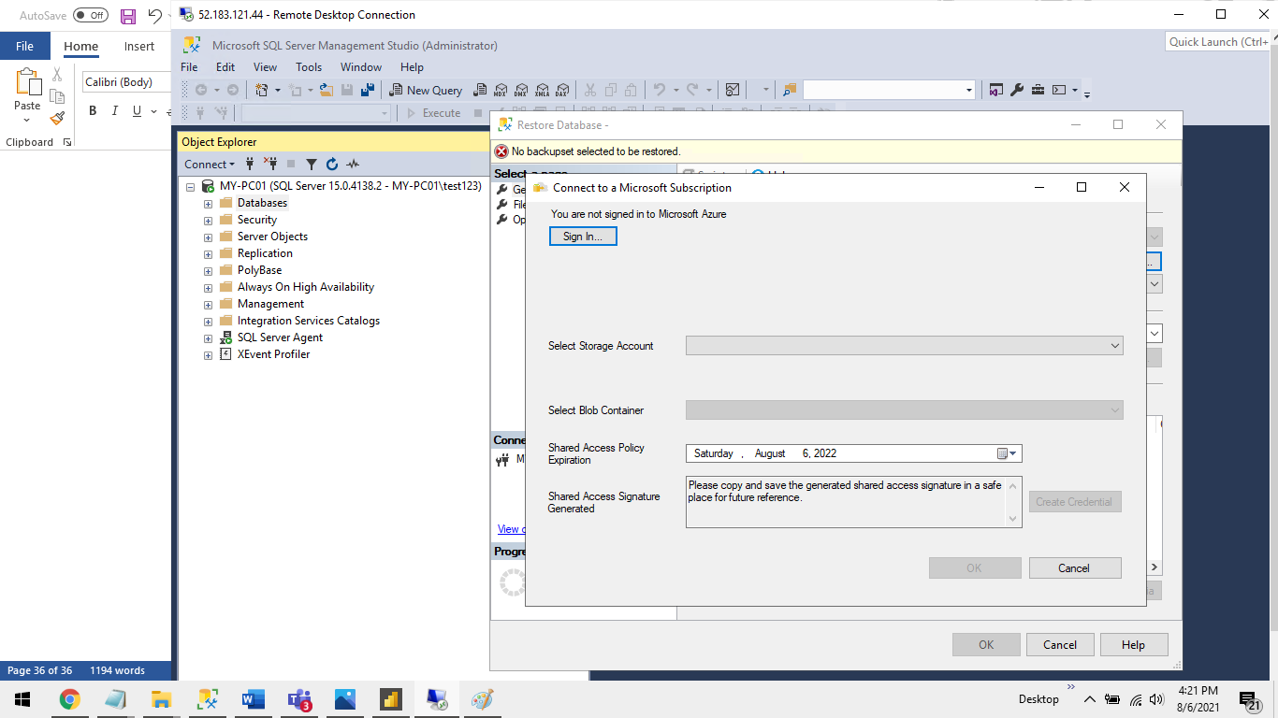

**Step11.5** Enter Email address.



**Step11.6** Enter password and Click on **Sign in** Button

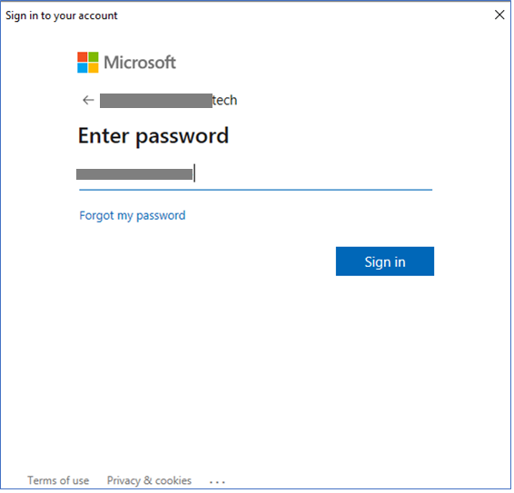

**Step11.7** Enter data as given below.

**Select a Subscription to use**:<select from drop-down>  
 **Select Storage Account**: <select Storage account from drop-down>  
 **Select Blob Container**:<Select Container from drop-down>  
 Click on **Create Credential** button and then click on **Ok** Button.

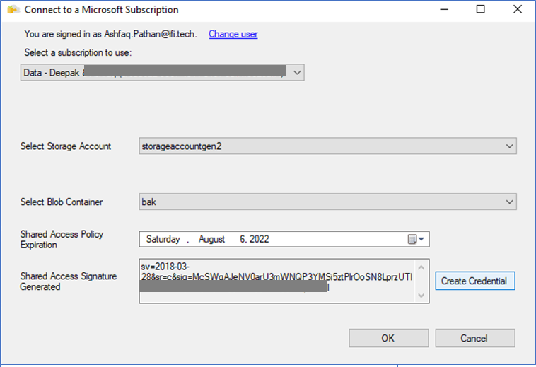

**Step11.8** Click on **OK** Button**.**

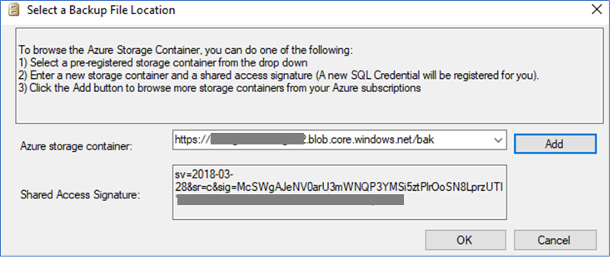

**Step11.9** Select **.bak** file from bak Container and click on **ok** button.

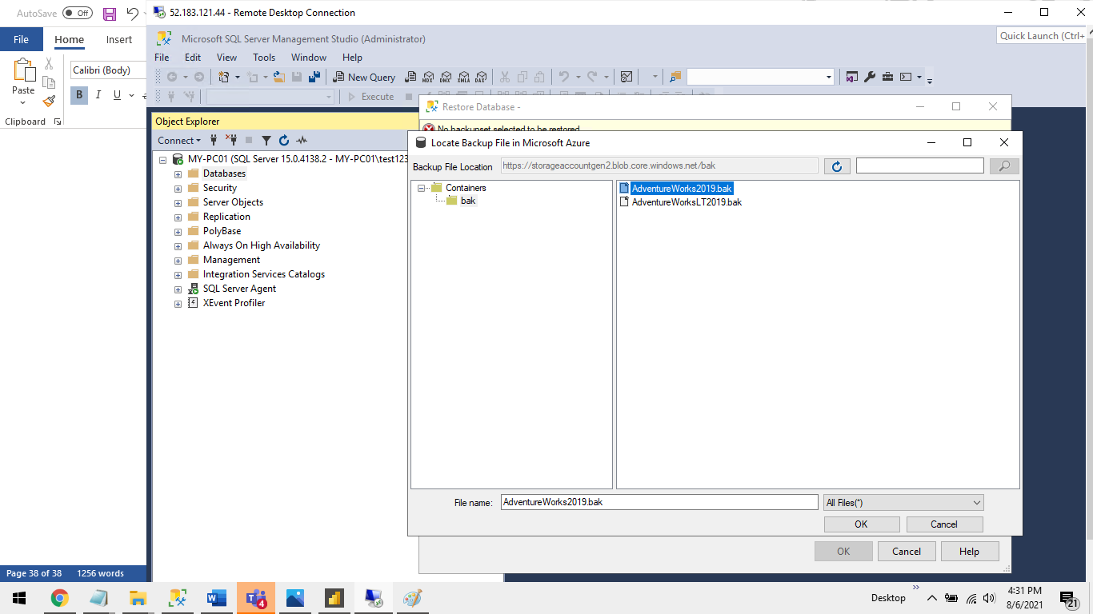

**Step11.10** Click on **Ok** Button.

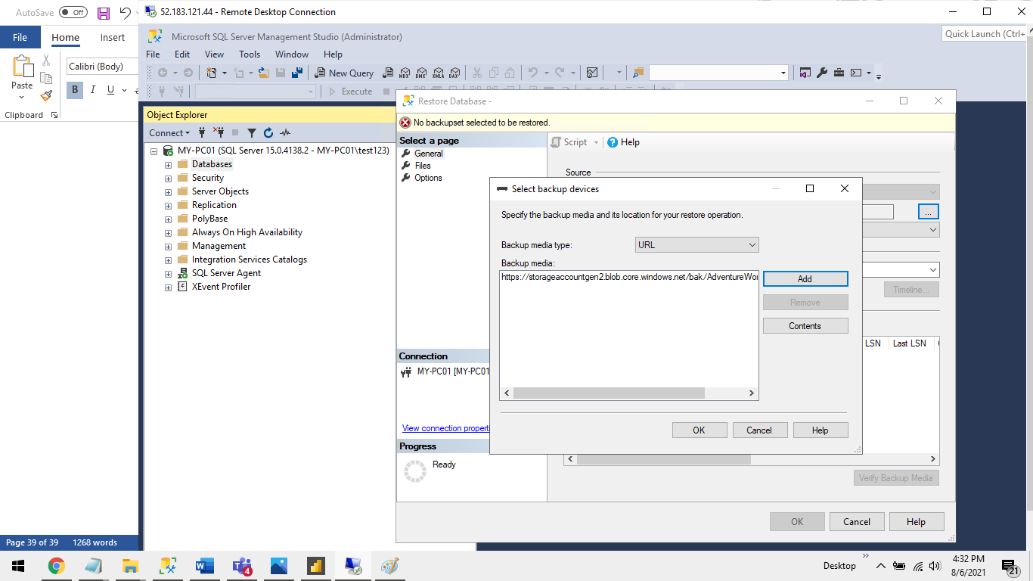

**Step11.11** Click on Ok Button.

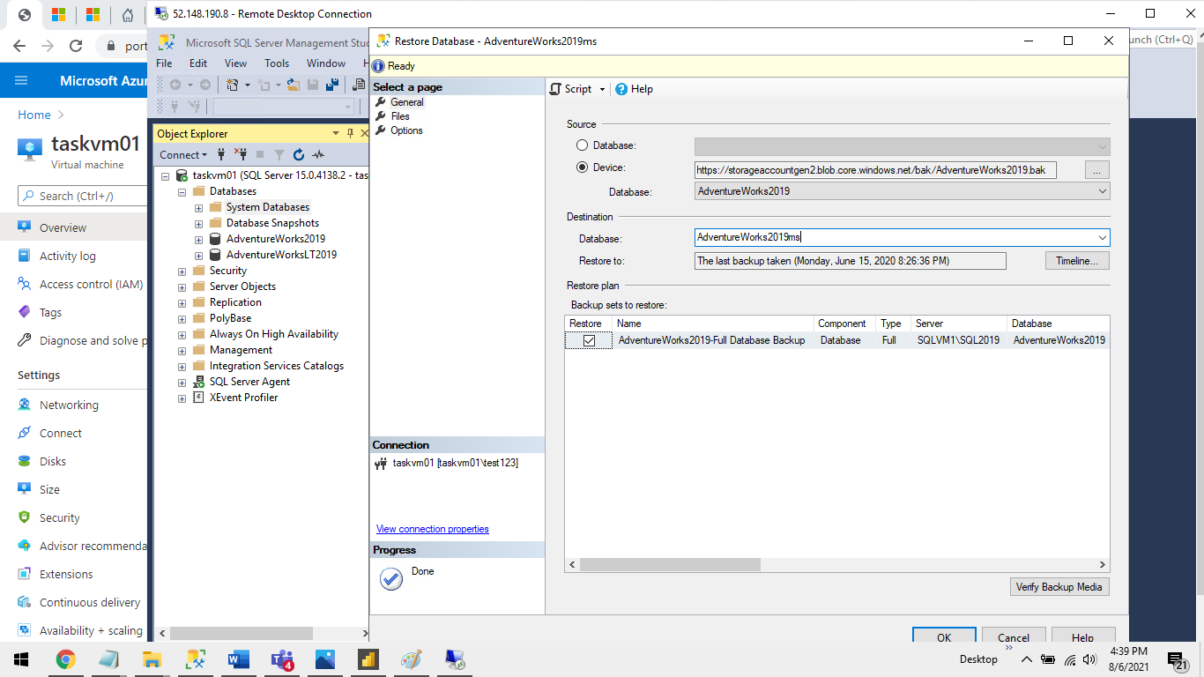

**Step11.12 Click on Ok Button.**

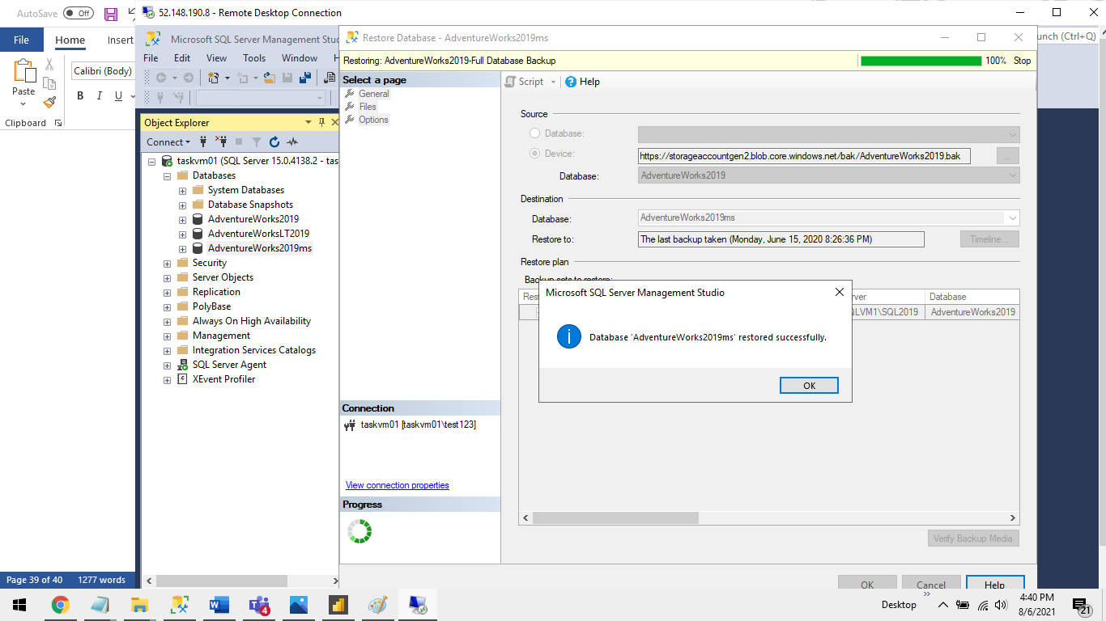

**Step11.13** Database restore Done properly as we can see tables in the table folder.

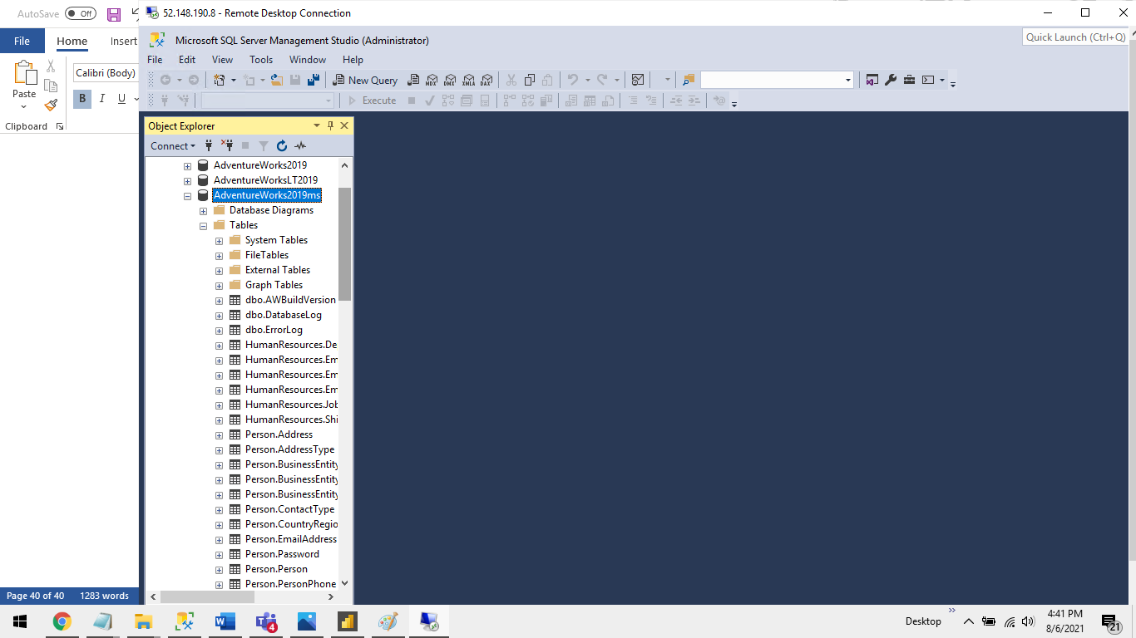

**G we will connect the Azure SQL-VM database to Power BI Desktop.**

**Step1** Open Power BI Desktop.



**Step2** Click on “**SQL Server**” from “**Home**” Tab.



**Step3** Enter VM IP Address in Server text field. and Click on **OK** Button.

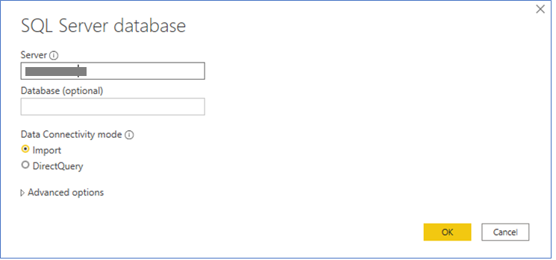

**Step4** Click on **Database** and enter VM **User id** and **Password.** and Click on **Connect** Button**.**

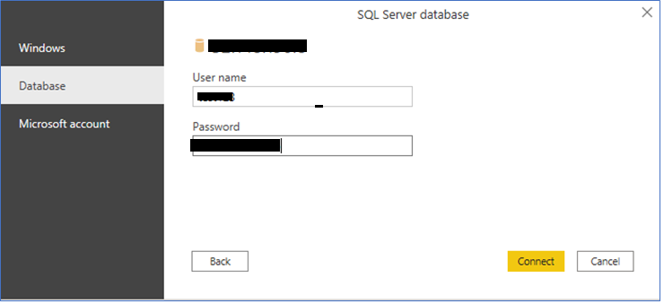

**Step5** Select **Database** and **Tables** and Click on **Load** Button.

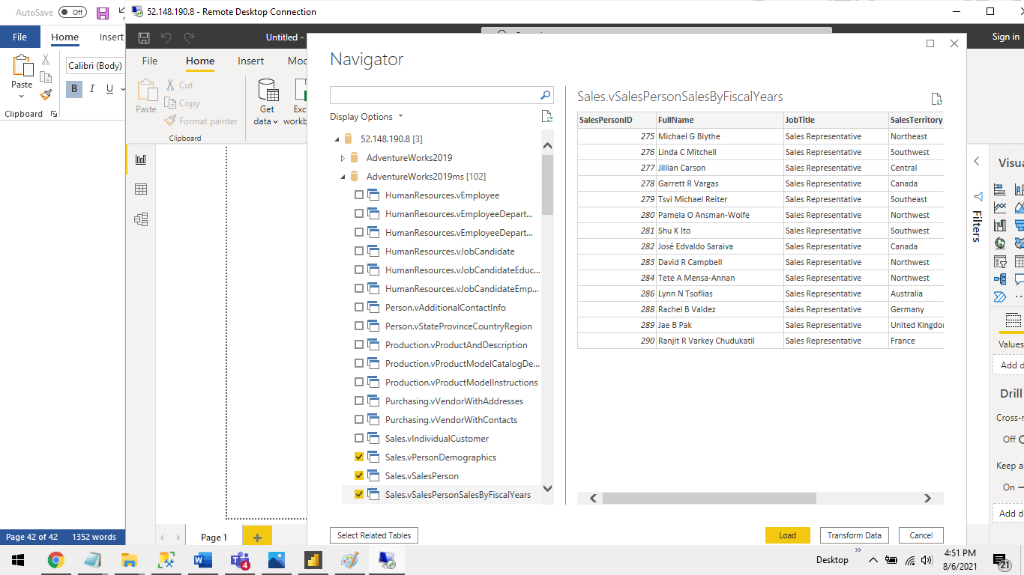

**Step6** This Will Load Tables in Power BI.

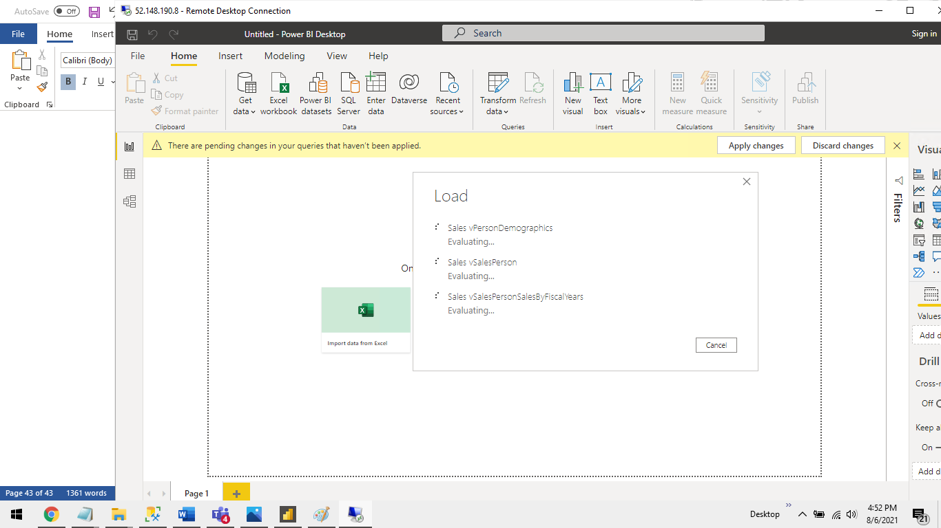

**Step7** You can See **Table** in **Fields** in Power BI.

